Fish4Knowlege: a Virtual World Exhibition Space
for a Large Collaborative Project
Yun-Heh Chen-Burger, Computer Science, Heriot-Watt University and
Austin Tate, Artificial Intelligence Applications Institute, University of Edinburgh
and Virtual University of Edinburgh (Vue)

Abstract
In this presentation, we will talk about how we came to build our Fish4Knowledge (F4K) Gallery and an Underwater Aquarium, what we have provided in the aquarium and how it is relevant to our research work. The F4K gallery and its underwater aquarium is an experimental outreach platform to showcase the scientific work that we have carried out in a large collaborative international project. We will also talk about the issues that we have faced when using virtual worlds such as Second Life and OpenSimulator for educational outreach.
Introduction
The technologies for 3D interactive environments for multiple simultaneous users are quite advanced and virtual environments are widely used in many areas, including gaming, movies, animation, design, engineering, health and safety testing, informational, educational and multi-media applications. As the Fish4Knowledge project [1][2][3] has an important visual aspect to show marine life observations, it was a natural and useful step to be able to use such media to communicate the Fish4Knowledge project results, in addition to traditional academic outlets, such as web sites, scientific conferences and journal publications.
Among several 3D virtual world environments, we chose initially to build our project exhibition in a virtual exhibition gallery in Second Life (SL) for several reasons. One of the project partners, the University of Edinburgh, already owned virtual land in SL. On this land, there is the well-established Virtual University of Edinburgh (Vue), sponsored and presented by several schools and institutes within the university, including the School of Informatics, Information Services, e-Learning, Business School, Veterinary Medicine, Social and Political Sciences and Alumni Services, etc. In addition, on a part of this virtual land, some of the distance learning courses are supported directly through the Vue facilities. Interested readers are directed to http://vue.ed.ac.uk for more details of the Virtual University of Edinburgh.
The University of Edinburgh, at the time of consideration, already had a long history of SL deployment and its virtual land is well populated and used. It was therefore useful for F4K to build its virtual gallery as a part of Vue. Furthermore, and probably more importantly, is the fact that SL allows its users to relatively easily develop and program its environment. That was essential for us, as we planned to provide a tailored 3D environment to suit our needs.
As a result, we initially selected Second Life as the experimental platform to host our F4K 3D Virtual Gallery. We were also able to secure a plot of virtual land within Vue to build our gallery. Following this initial successful effort in Second Life, we replicated and built the F4K Gallery using the OpenSimulator platform, on the OpenVue grid.
Purpose of the Fish4Knowledge Virtual World Exhibition
What distinguishes this 3D virtual project demonstration area from our other standard project (Internet-based) web sites is that the project demonstration is intended to be fun, interactive and educational. It is not just for academics, but also for everyone who has an interest in marine life and ocean conservation. We intended to use this virtual platform to attract younger people and their educators who have an interest in using computing technologies for educational purposes to get them curious about our work and marine research in general.
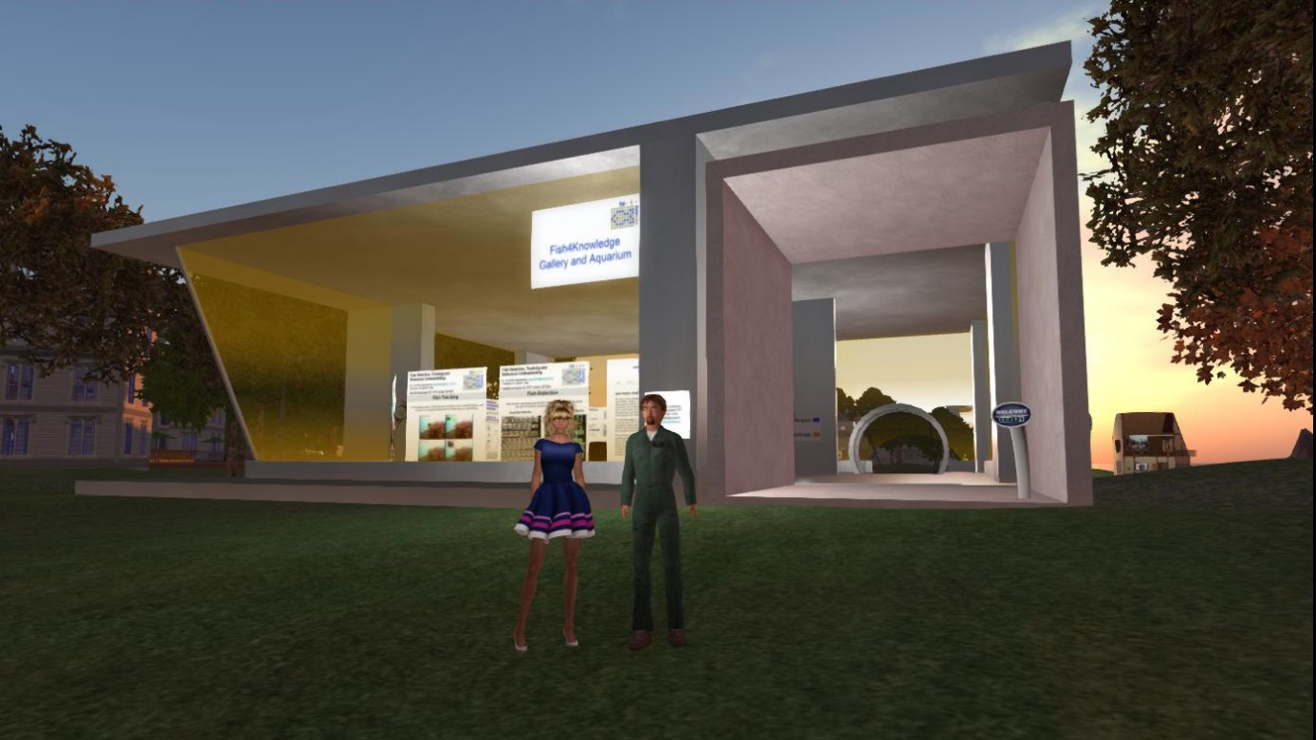
Figure 1: Front of the F4K Virtual World Gallery
The Fish4Knowledge virtual exhibition gallery is situated at a beauty spot by a lagoon at the heart of the Vue virtual world facilities. In this gallery, visitors are able to “walk” leisurely around our virtual building, via their avatars, to read about our project work and watch our underwater fish monitoring movies that were recorded at our observation sites. They are able to learn and be entertained in a beautiful surreal environment where the sunset is reflected by the nearby lagoon shining through the large floor-to-ceiling glass window walls. Alternatively, visitors can choose to visit our gallery on starry nights, or at any other times of the (virtual) day to enjoy the shimming sea waves. Figure 1 shows the front of the F4K virtual gallery.
Fish4Knowledge Virtual World Gallery – Ground Level
Upon arriving at the ground level exhibition hall, the visitors can “sit” on our comfy virtual sofas to enjoy the surrounding or walk around our scientific posters to view them. They can interact with or meet others there; or arrange to meet project representatives to talk about the project and its results. Figure 2 shows the ground level project exhibit area.
Once a poster is selected for viewing, the visitor can click on it to open a web page with more details of that exhibit. Currently, there are about a dozen scientific project posters on display, with topics ranging from high performance computing, video and image processing, human-computer interactions, marine biology and intelligent scientific analysis workflow programs.
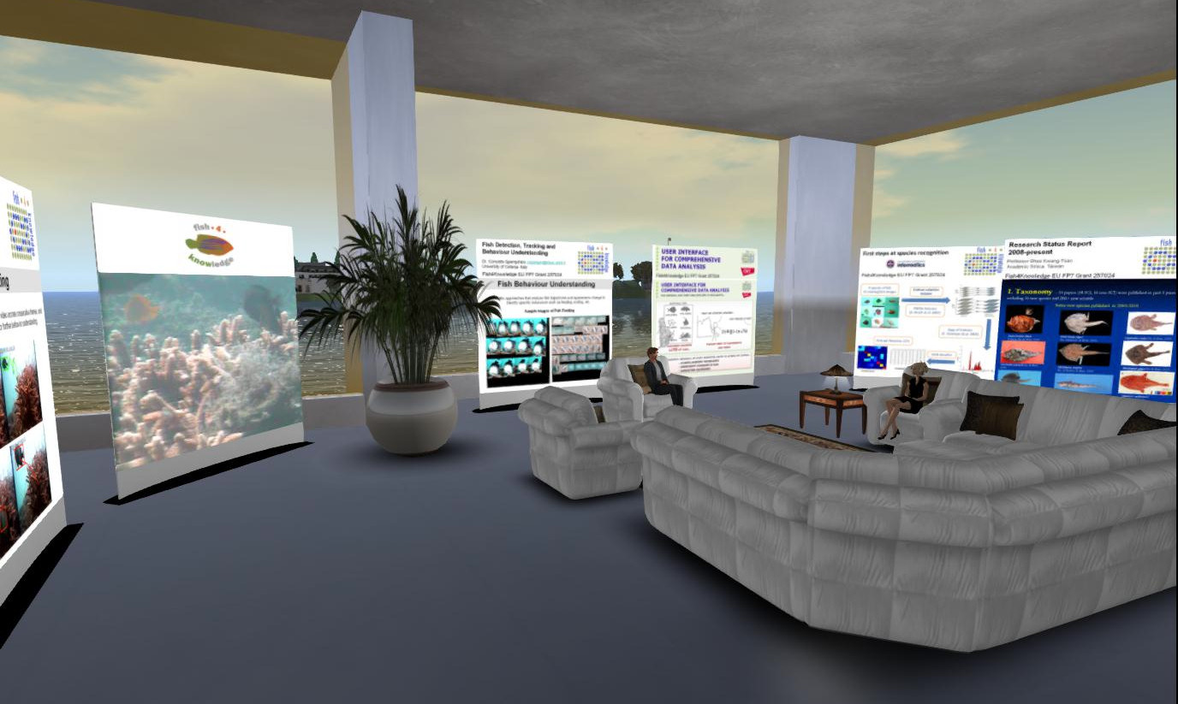
Figure 2: View of the Ground Level Exhibition Hall
On the left hand side of Figure 2, one can see a media screen displaying a looped marine life video that was captured under the coastal sea off the South of Taiwan. This video is an example of the videos that the Fish4Knowledge team process.
Fish4Knowledge Virtual World Gallery – Underwater Aquarium
In one corner of the F4K gallery, as shown in Figure 3, there is a passageway that leads visitors down to an underwater virtual aquarium. We call this underwater aquarium the “Virtual Fish Lab”. Here we exhibit example fish that we observe in real life. Some of our virtual fish are interactive and will react in different ways when stumbled upon or interacted with. Our virtual fish will “talk” to visitors about their lives, via some simple conversational skills.
Figure 4 shows the interior of the underwater level. On this lower level, there is a “porthole” style media screen again displaying a looped marine life video that was captured in the coastal sea off South Taiwan and is meant to show the type of a video imagery that have been captured and processed by the Fish4Knowledge Team.

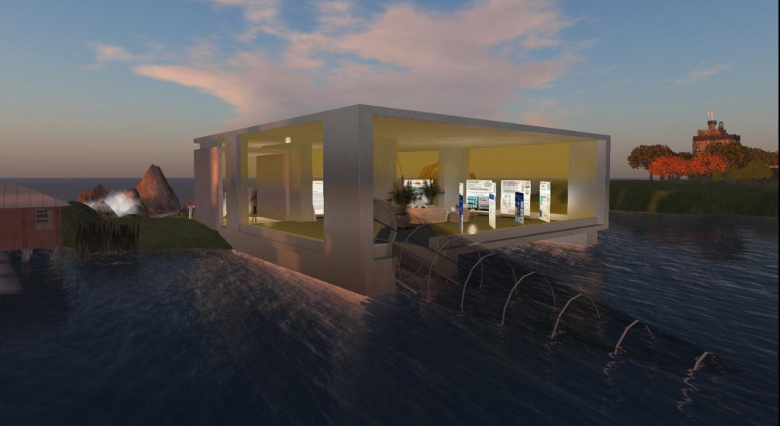
Figure 3: Tunnel to the Underwater Level
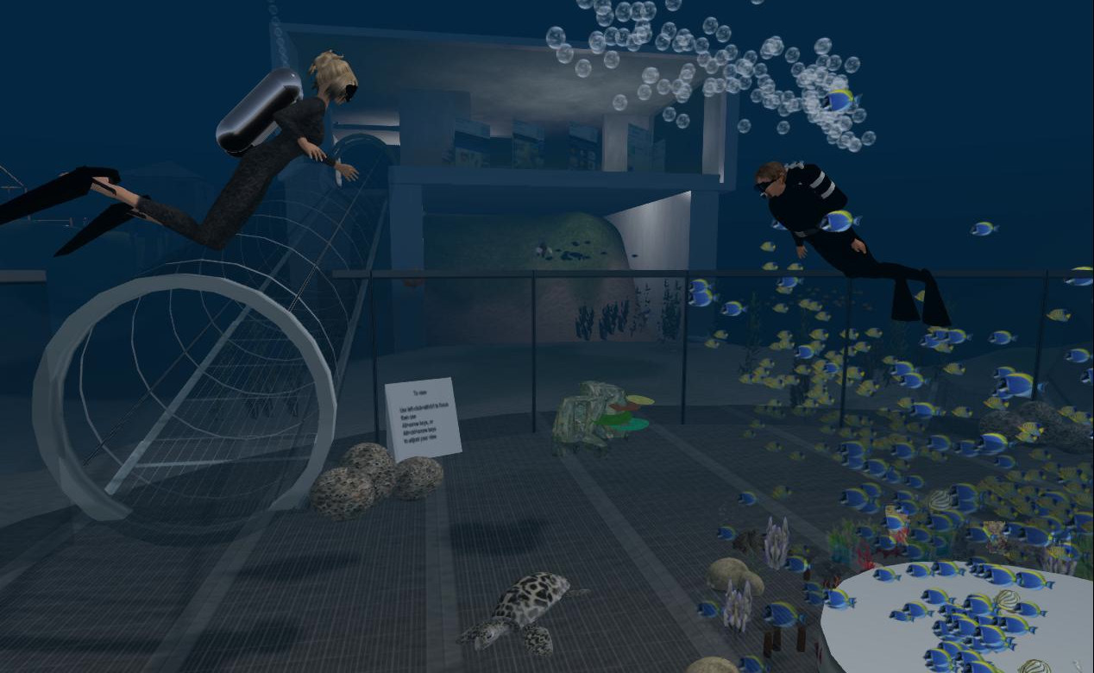
Figure 4: View within the Underwater Level
Fish4Knowledge Virtual World Gallery in OpenSimulator
The OpenSimulator-based “Openvue” (Open Virtual University of Edinburgh) grid [4] and the easily accessible “OSGrid” [5] have replicas of the F4K gallery.
The F4K project page at http://www.aiai.ed.ac.uk/project/f4k provides URLs to access to the F4K galleries and their underwater aquariums on OpenSim. An “OpenSim Archive” (OAR) file has also been created to support the replication of such facilities.
Fish4Knowledge Virtual World Gallery in Virtual Reality
The recent development of Virtual Reality (VR) Head Mounted Displays (HMDs) such as the Oculus Rift has opened up the possibility of more immersive experiences in facilities such as the F4K gallery and underwater aquarium. Virtual World viewers such as CtrlAltStudio [6] support 3D stereoscopic and VR HMD rendering as shown in Figure 5. Such interesting new technologies provide our visitors with a fresh way of exploring the gallery and our surreal underwater aquarium.
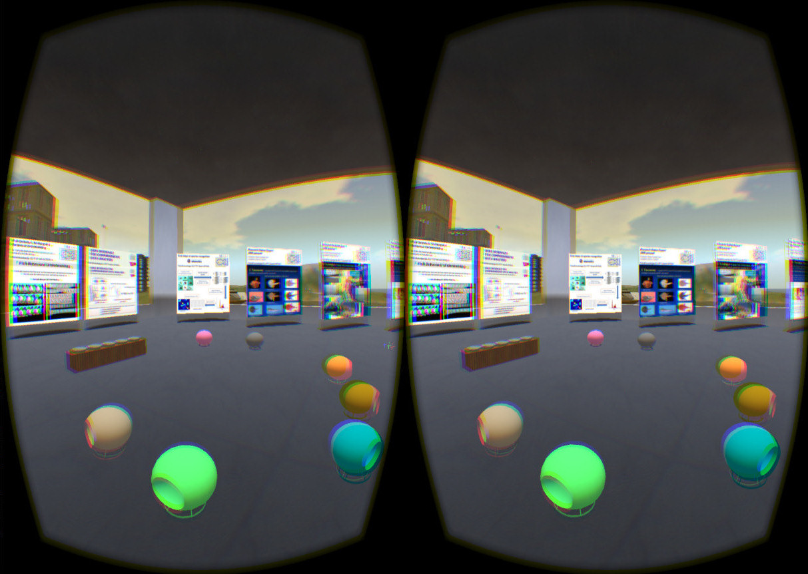
Figure 5: Oculus Rift Virtual Reality View
Issues Encountered in the Development of the F4K Virtual World Facilities
The central design idea of the underwater virtual aquarium is to provide a fun, interactive and educational space that gives its visitors a “surreal” experience - in that visitors can “walk about”, “touch” things, interact with objects or “talk” with virtual fish. When there is more than one visitor in this space, people can choose to share their experiences through Second Life and OpenSimulator’s live voice and text-chat facilities. When appropriate, the Fish4Knowledge team has run events and can hold future exhibition events where project works are presented. This learning experience is intended to be different from those provided by conventional publications, web sites and 2D media.
What we have encountered are the difficulty of introducing new users to the complexities of the viewer interface, especially when they lack any game playing experience or have lower power computers. Voice set up can be especially difficult.
We have also found that the promotion of the facility to the potential community of interest is difficult even with the various social interaction mechanisms used by virtual worlds like Second Life and the OpenSimulator community. One problem was also the age limitations set for Second Life users which meant that we could not attract primary and secondary school children to our site. Nevertheless, our real-life project had attracted many marine scientists and enthusiasts’ interests that we continue to receive feedback. If possible, we plan to create follow-up projects, when we will consider how to enhance our current set up in the virtual world to encourage more participants.

Useful Web Resources
- Detail of the Fish4Knowledge project can be found at http://fish4knowledge.eu
- Access to the Fish4Knowledge Virtual World Gallery and Aquarium in Second Life and OpenSimulator can be obtained via http://www.aiai.ed.ac.uk/project/f4k/

Acknowledgements
We would like to thank the OpenVCE.net project for the building shell and the Virtual University of Edinburgh (Vue) for co-sponsoring the cost of the virtual land in Second Life and for hosting the OpenSimulator servers which host copies of our gallery.
Fish4Knowledge is funded by the European Union Seventh Framework Programme [FP7/2007-2013] under grant agreement 257024, addressing Objective ICT-2009.4.3: Intelligent Information Management, Challenge 4: Digital Libraries and Content. The University of Edinburgh and research sponsors are authorised to reproduce and distribute reprints for their purposes notwithstanding any copyright annotation hereon.
We also would like to thank NCHC (National Center for High-performance Computing), Taiwan and Academic Sinica, Taiwan, for their efforts in capturing those valuable under-water marine life videos and their tireless endeavours to combat regular typhoons and open sea conditions in maintaining the high quality of videos, to assist us achieve the best possible processing results.
References
[1] B. J. Boom, P. X. Huang, C. Spampinato, S. Palazzo, J. He, C. Beyan, E. Beauxis-Aussalet, J. van Ossenbruggen, G. Nadarajan, J. Y. Chen-Burger, D. Giordano, L. Hardman, F.-P. Lin, R. B. Fisher: “Camera Surveillance for Monitoring and Analysis of Fish Populations”, Proc. Int. Workshop on Visual Observation and Analysis of Animal and Insect Behavior (VAIB), in conjunction with ICPR, Tsukuba, Japan, November 2012.
[2] Gayathri Nadarajan, Yun-Heh Chen-Burger, Bob Fisher: “Semantics and Planning Based Workflow Composition for Video Processing”. Journal of Grid Computing, special issue on scientific workflows, 2013.
[3] Fisher R. B., Chen-Burger, Y-H., Giordano, D., Hardman, L. and Lin, F.P. (eds.) (2015) “Fish4Knowledge: Collecting and Analyzing Massive Coral Reef Fish Video Data”, October 2015, Intelligent Systems Reference Library, Springer.
[4] Openvue, the Open Virtual University of Edinburgh – http://vue.ed.ac.uk/openvue
[5] OSGrid, http://osgrid.org
[6] CtrlAltStudio Viewer – http://ctrlaltstudio.com

