OAR Converter: Using OpenSimulator and Unity
as a Shared Development Environment
for Social Virtual Reality Environments

Fumikazu Iseki Austin Tate
Tokyo Univ. of Info. Sci., Dept. of Informatics, AIAI, School of Informatics, University of Edinburgh,
Japan United Kingdom

Daichi Mizumaki Kohei Suzuki
Tokyo Univ. of Info. Sci., Dept. of Informatics, The Daiichi Information Systems Co., Ltd.,
Japan Japan

Abstract

We developed OAR Converter, a conversion system to load OpenSimulator Archive (.oar) files into Unity for use in Unity-based projects. This system allows the user to load 3D world data created in OpenSimulator into Unity on a region-by-region basis, and to ultimately output the data from Unity in a variety of formats. These features allow us to treat the pairing of OpenSimulator and Unity as a shared development environment, which simplifies the low-cost creation of 3D virtual worlds that can be used for graphical visualizations and social virtual worlds or social virtual reality experiences.

- Introduction.
Several approaches exist to construct three-dimensional (3D) worlds in a computer system at low cost. Representative methods include using the systems Unity [1] and Unreal [2], which are so-called game engines.
Alternatively, one can use so-called metaverse systems. At present, the widest used metaverse-type examples of 3D virtual space (virtual world) platforms are Second Life™ [3], offered by Linden Lab, and OpenSimulator (also known as OpenSim[4]), which is an open-source platform largely compatible with Second Life. But others are now emerging such as High Fidelity, SpatialOS, Sansar and Sinespace.
These game engines and metaverse platforms each have advantages and limitations. For example, Second Life and OpenSimulator allow users to construct 3D spaces through collaborative efforts over a network using in-world real time content editing tools, while Unity and Unreal allow the conversion of created 3D spatial data for use in webpages and applications so that general users can easily reference it.
Adopting the game engine Unity and the metaverse OpenSimulator, the present study proposes a construction environment for 3D spaces that takes advantage of the two systems’ respective properties.

- Unity and OpenSimulator
  - Unity
Offered by Unity Technologies, Unity is an integrated game development environment, which is a kind of game engine. Two editions exist as of the time of writing. These are the Professional Edition and the Personal Edition, the latter of which can be used for free despite offering almost all of the major functions of the former.
Several characteristics of this software are notable, but we focus our attention on two functions: direct loading of 3D objects using Collaborative Design Activity (Collada) data (.dae files; a 3D-data-interchange file format) [5], and the output of complete 3D creations as a webpage or application. Unity does operates a shared data space for development, but it is difficult to use due to the program’s implementation of this feature.

  - OpenSimulator
OpenSimulator is an open-source virtual world or metaverse system developed by an open-source community; it is the most widespread open-source metaverse system. Originally, OpenSimulator was based on Second Life’s protocols though extensions have been made to reflect its use in educational and other environments. However, importantly, OpenSimulator can use variants of the Second Life Viewer (display client) program, which itself is released under a flexible open-source license. There is also an optional OpenSimulator facility called the “Hypergrid” which allows the connection of separately provided or managed OpenSimulator grids. According to the metaverse-related news site Hypergrid Business, over 70,000 standard Second-Life sized region equivalents (256m X 256m) exist worldwide across the various separate OpenSimulator “grids” as of January 2016 [6].
Considering OpenSimulator as a system to construct 3D spaces, its most characteristic feature is that users can jointly perform development in real time while viewing sharing their creations over a network. Essentially, multiple users can proceed with development in a simultaneous and progressive manner while confirming the properties and positions of objects and landscapes in advance.
Its weaknesses, on the other hand, include the construction of the system itself and complicated access methods for normal (non-developer) users. General users must take complex actions in order to see 3D spaces constructed in OpenSimulator (account and avatar creation through a web interface (F.Iseki and M.W.Kim, 2011 [7]), viewer installation and configuration, etc.), and so beginners often become discouraged midway. Many ask why they cannot simply enter and view the 3D worlds and interact with others in them via a web browser, as this is a common access method nowadays.
Regarding the construction of 3D worlds on the OpenSimulator platform system itself, options are available to add 3D space in the form of one or more regions onto grids run by others, such as using the open grid OSGrid [8]. This allows users to connect regions for free, as well as allowing avatars to be created and used for free. Such grids usually run on community donations. This ability to add regions onto grids managed by others is useful and continues to increase for users who cannot construct or manage everything by themselves. Often basic building resources and 3D models are provided in asset stores on such grids, and many provide these assets freely to other builders and users.

  - Shared Development System
Unity and OpenSimulator each have advantages and disadvantages as systems for 3D spatial construction. If one could load data jointly created in OpenSimulator into Unity and then output it as a webpage or application, it would be possible to construct a development environment that leverages the strengths of both systems.
To achieve this, we have developed an open-source OpenSimulator-to-Unity data conversion system. The developed system allows us to treat OpenSimulator and Unity as a single shared-development, visualization environment.

- Preceding Developments
  - Case by Tipodean Technologies
In 2011, a virtual world converter was created by Tipodean [9] to take saved OpenSimulator regions as OpenSimulator Archive (OAR) files and convert the content to Collada mesh for import to Unity. It was used to create a number of demonstrations using academic virtual world regions from Rutgers University, the US National Oceanic and Atmospheric Administration (NOAA) and the Virtual University of Edinburgh’s Open Virtual Collaboration Environment (OpenVCE) open source available region (see Figure 1). The Tipodean converter did not attempt to convert all content but was able to convert the main primitives and mesh used in OpenSimulator builds, and was able to bring across the core visual appearance of a region, so that further development could be undertaken in the Unity development environment and editor.
Note that the Tipodean conversion service became unavailable in 2015 but examples are available at http://converter.tipodean.com and http://converter.tipodean.com/unity3d/
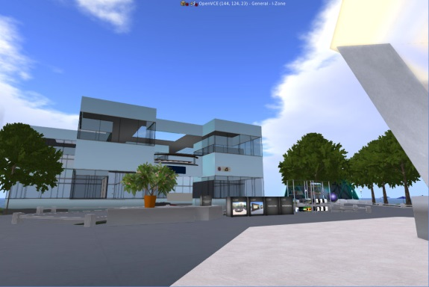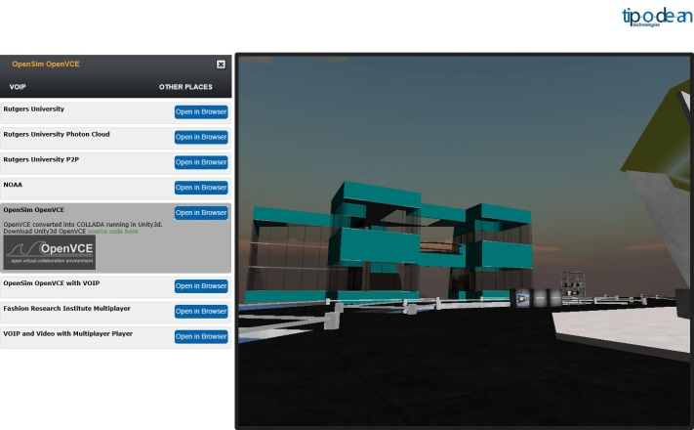
Figure 1: OpenVCE Region in OpenSimulator and via Tipodean Converter to Unity

  - Export of 3D Mesh via a Compatible Viewer
Singularity Viewer [10] is an open source virtual world viewer (client software) that can be used with OpenSimulator and Second Life. The Singularity Viewer supports the export of Collada format and other 3D formats on an object-by-object basis, but this does not mean it supports the output of all parameters.
The unit of output is the object, and the processing does not take into account system-side considerations of importing the output data (Collada compatibility) to other platforms.

- Conversion System
  - Outline of Conversion System
Figure 2 shows an outline of our developed conversion system. Region data, the management unit in OpenSimulator, can be output as an .oar (OpenSimulator Archive) file [11]. OAR Converter, a tool we previously developed [12] [13], outputs this OAR file on an object-by-object basis as Collada data (.dae). Conversion also proceeds such that every texture file used for the object can be used in Unity.
Figure 2: Conversion System Overview

OAR Converter
OAR
File
Open
Sim
Collada
File
Editor Extension
Unity
SelectOARShader

Converted .dae file(s) and texture file(s) are then loaded into Unity via “SelectOARShader”, a Unity editor extension created for use with OAR Converter. “SelectOARShader” is used to make decisions about which shader to use and about object attributes in Unity on the basis of the filenames (and pathnames) of data.

  - Details of Object Conversion
All region information from OpenSimulator is included in the .oar file. OAR Converter retrieves vertex data separately for each Prim [15], Sculpted Prim [16], and Linden Mesh [17] object. After searching for duplicate vertices in the resulting octrees, the program then generates triangular polygons and converts them to Collada data. The step of checking for duplicate vertices is not essential, but is included because data could otherwise grow very large in size, depending on the objects. For the terrain or ground, we generate triangular polygons from elevation data and convert to Collada mesh data.
When these data are imported separately into Unity using “SelectOARShader” normal solid objects are loaded with collider attributes. For “phantom” objects, on the other hand, collision detection is not performed, and so the conversion process is similar to that of normal objects, except that the results are output to a dedicated (“Phantoms”) folder. The processing of this data without collider attributes is performed separately when the data in this folder are loaded into Unity.
The details of the tree generation algorithm in OpenSimulator are unclear for Linden Labs style trees and plants. They are handled specially in Second Life compatible viewers and are not normal objects. Thus, Linden trees and plants are represented in combination with a special Primitive representing the type of tree of plant, without using the conversion algorithm. Regarding avatars and Non-Player Characters (NPCs), drawing avatars is a function of the viewer, which OAR Converter does not yet support (although integration with the viewer is under investigation).
Table 1 shows a list of conversion functions supported by OAR Converter. OpenSimulator repeatedly processes small-size image data dynamically to display ground textures, but loading ground textures into Unity requires there to be only one image. Attempting to maintain high resolution causes data to grow extremely large in size, and so we opted to reduce resolution in consideration of OAR Converter and Unity performance.
Table 1: OAR Converter Conversion Functions
Target | Conversion | Notes
Prim | Supported
Sculpted Prim | Supported
Mesh | Supported
Tree/Grass | Limited Support | Linden Tree generation algorithm is not used
Flexible Prim | Limited Support | Flexible parameters are not supported
Terrain | Limited Support | Low-resolution textures
Avatar/NPC | Not Supported
Water | Not Supported
Script | Not Supported

In addition, OAR Converter ignores flexibility-related parameters from Flexible Prim objects; they are converted as normal Prim objects.
The implementation and improvement of conversion functions not supported or restricted above constitute topics for future research.

  - Details of Texture Conversion
OpenSimulator saves texture data internally in JPEG 2000 (.jp2, .jpx) format. But Unity cannot handle JPEG 2000 format. Thus, OAR Converter performs the task of converting texture files in JPEG 2000 format to common image formats at the same time as it converts object data.
In consideration of the properties of Sculpted Prim objects (i.e., their use of pixel data from images as 3D coordinate data), OAR Converter converts them via lossless compression to .tga files, which have a simple format structure.
We use OpenJPEG for JPEG 2000 conversion processing [17]. OpenJPEG has two versions, Version 1 and Version 2, which both have compatibility issues for a proportion of processing tasks. In other words, some images can be processed by Version 1 but not by Version 2, and vice versa. In its default state, therefore, OAR Converter is designed to perform processing internally using Version 1, and if this results in un-processable images it uses Version 2 (if installed) via external commands.

  - Output of .dae Files
Collada is a general-purpose 3D data conversion format, and so theoretically OAR Converter can be run without any special consideration regarding Unity as a target. However, Unity does not support all Collada functions (e.g. it cannot import all parameters). Furthermore, depending on Unity specifications, there are conditions under which, for example, material color information fails to import correctly into Unity unless the Collada protocol is partially violated.
Specifically, according to the Collada digital asset schema [18], multiple <diffuse> elements cannot exist within a <phong> element. Therefore, if Collada data is created according to the digital asset schema, a <diffuse> element’s child <texture> and <color> elements must be described within the same <diffuse> parent element. However, Unity ignores <color> element parameters if they are described in this way. To make Unity correctly load <color> element parameters, separate <diffuse> elements corresponding respectively to <texture> and <color> elements must be independently prepared and described. That is, the system needs to be able to use multiple <diffuse> elements inside <phong> elements, but this violates the Collada protocol.
Considering these conditions, the default behavior of OAR Converter is to output a .dae file (in which the Collada protocol is partially violated) for use in Unity. In addition, filename extensions are added to texture filenames in anticipation of their loading into Unity (see below).

  - Import to Unity with Material Parameters
When importing external data into Unity, texture filenames become material filenames by default. Materials contain all kinds of information, including not only the texture itself, but also its geometric parameters, color, transparency, and reflectance. However, Unity prioritizes only the texture parameters last loaded when texture files have the same filename, and materials that were originally different get processed as a single material category.
In addition, Unity cannot read all parameters from .dae files. For example, it ignores information such as reflectance, glow, and brightness contained in .dae files.
Further, OpenSimulator has only one kind of “shader” that it can apply to objects (and materials). In Unity, on the other hand, the user can select various shaders for each material. Thus, objects created in OpenSimulator cannot be accurately represented in Unity unless an appropriate shader is selected. The user could manually configure the shader for each object, but this would constitute a fatal flaw in the conversion system when one considers the time and effort involved.
Summarizing the above points yields the following two issues.
- If material parameters differ, even for the same texture file (name), the user must force Unity to recognize them as different materials.
- The program must be able to, as well as possible, automatically select an appropriate shader based on the material parameters.

To resolve the first problem, major material parameters are converted to a text string and appended to the texture filename when texture files are converted by OAR Converter for later use when they are loaded into Unity. Stringified parameters in OpenSimulator are as below.

1. Color (Red), 1 Byte
2. Color (Green), 1 Byte
3. Color (Blue), 1 Byte
4. Transparent, 1 Byte
5. Alpha Cutoff, 1 Byte
6. Shininess (Reflectance), 1 Byte
7. Glow, 1 Byte
8. Bright, 1 Byte
9. Light (Luminescence), 1Byte
10. Texture Shift in U Direction, 2 Bytes
11. Texture Shift in V Direction, 2 Bytes
12. Texture Scale in U Direction, 2 Bytes
13. Texture Scale in V Direction, 2 Bytes
14. Texture Rotation, 2 Bytes
15. Object Classification, 1 Byte

Object Classification indicates the distinction between normal objects (O), trees (T) and grass (G), and ground (E). Four spare bytes (for future extensions) are added to these 20-byte parameters, and all 24 bytes are converted to a Base64 string (yielding 32 bytes after conversion). The character ‘/’ is typically allowed to appear in Base64 strings, but it cannot be used in filenames; thus, ‘/’ is replaced with ‘$’ when it appears. In addition, ‘_’ is used as a separator character when appending the parameter string, in order to distinguish the new filename from the original filename. Figure 3 shows an example filename (a universally unique identifier ) with an appended parameter string.
cc98df7f-d21c-45b3-aca0-4ac36be289c5_AAAAGQAAAAAAAAAAAAAAAACjAQEAAABP.tga
Figure 3: Example Filename with Parameters Appended

Accordingly, materials with different parameters will be converted to files with different names, even if their texture data are the same. Hence, materials will be recognized as different materials (material names) when loaded into Unity.
To resolve the second issue, we utilize an editor extension in Unity. When loading external data into Unity, Unity can load the data once it has been processed by the editor extension. The editor extension lets users see shader designations and material names (i.e., filenames of texture files). Therefore, the original parameters can be reproduced by removing the Base64 string from the material name, and an appropriate shader can be selected according to the values of the parameters.
We created the Unity editor extension “SelectOARShader” in order to realize these functions and to add collider attributes to objects. This will obviously not always result in the best shader being chosen, but a better shader will be chosen at least, the result of which is expected to greatly reduce efforts spent on later manual configuration.

- Experience with Sample Conversions
5.1 Example of Conversion – Tokyo University of Information Sciences
Figure 4 shows the original OpenSimulator snapshot from a model of Tokyo University of Information Sciences and the resulting snapshot after conversion and loading into Unity.
The number of solid and phantom objects loaded into Unity (i.e., .dae file count) was 4,741, and the number of texture data (material data) files was 4,867. The conversion time required was about 9 minutes (PC; CPU: AMD Phenom IIX4 965 @ 3.40 GHz; Memory: 16 GB). Loading into Unity required an additional 45 minutes.
In this test case, only the shader for two materials (data for a fraction of tree leaves) was modified manually after data was loaded into Unity. In addition, problematic or erroneous conversion of object shapes did not occur as far as can be determined from visual inspection. 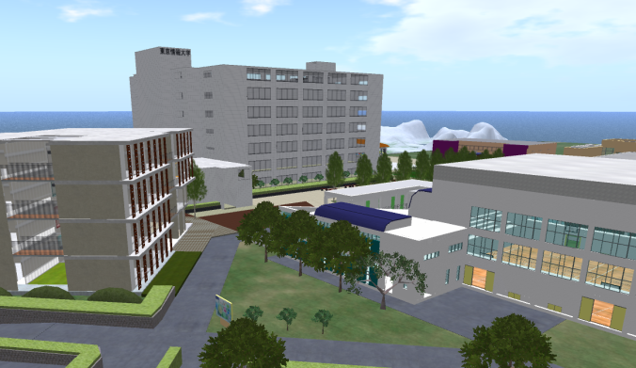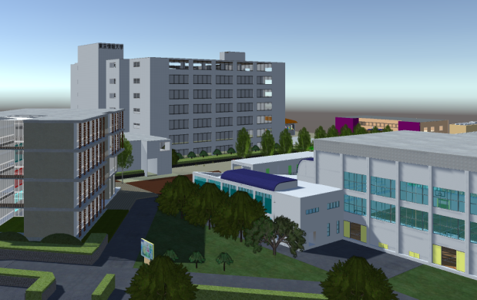
Figure 4: TUIS region in OpenSimulator and as Converted via OAR Converter to Unity

5.2 Example of Conversion – Virtual University of Edinburgh
A further test case was employed during the development of the OAR Converter to provide feedback during its development and refinement. The Virtual University of Edinburgh (Vue) OpenSim grid’s Open Virtual Collaboration Environment (OpenVCE) region, which was created by the OpenVCE community and Clever Zebra and is available open source (Tate et al., 2014)[19][20]. The OpenVCE region OAR was 40.8MB with 4,104 objects on the original OpenSimulator region. The OAR file was converted via the OAR Converter (see Figure 5).
The number of solid and phantom objects loaded into Unity (i.e. .dae file count) was 404 compound objects (made up of the original 4,104 sub-elements) and the number of texture data (material data) files was 896. The conversion time required was about 2 minutes (PC; CPU: Intel i7-3770 @ 3.40GHz; Memory: 16MB). Loading into Unity required an additional 6 minutes.
During development of the OAR Converter we were able to identify a number of issues through the trial conversion of the OpenVCE region as described at [13]. All these were addressed in the version subsequently released.
The OAR Conversion process does not bring across any active scripting, particle systems (for smoke, fire, etc.) or special light sources. Where important for the converted scene, these need to be added back into the resulting Unity project.
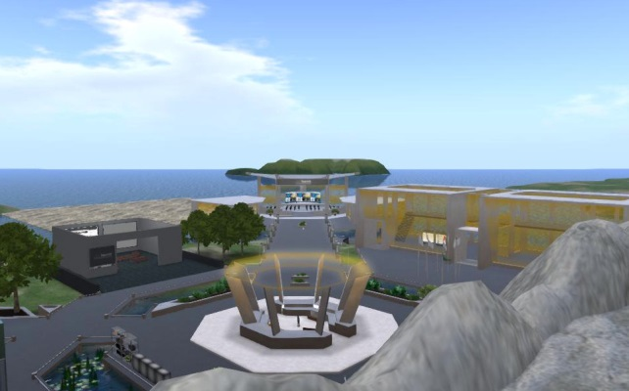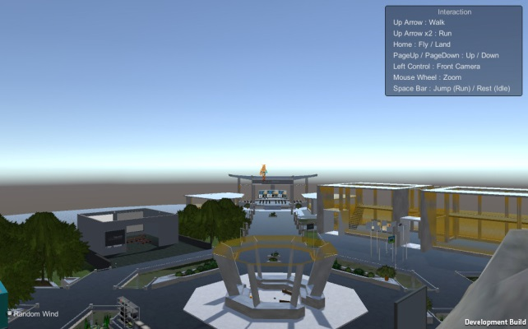
Figure 5: OpenVCE region in OpenSimulator and as Converted via OAR Converter to Unity
5.3 Using Conversions in Multi-User Virtual World and Social Virtual Reality Environments
OAR converted regions loaded into Unity can be used as a basis for 3D virtual worlds and VR experiences. Early experiments with the Unity-compatible SmartFoxServer[21] and Photon[22] were used to allow simple avatars to interact together in 3D virtual worlds spaces and try small scale social virtual reality experiences using the Unity Virtual Reality integration. But there are now a number of virtual worlds platforms that build upon Unity as their development tool and allow for avatar customization, social interaction, voice, etc. One such platform is Sinespace[23].
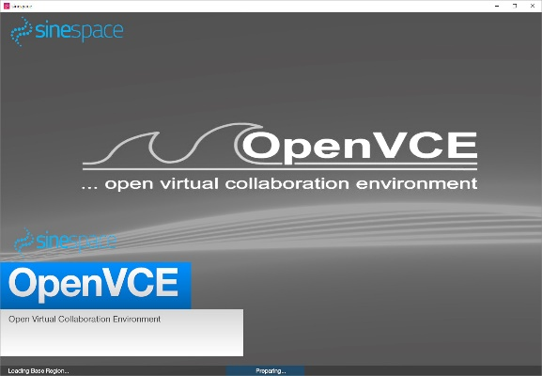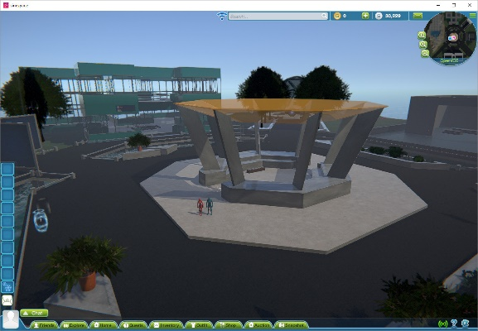
Figure 6: OpenVCE region converted via OAR Converter to Unity and used in Sinespace
Unity projects created from OAR converted may have many copies of the same texture with file names used to encode material properties from OpenSimulator utilized by the OARConvShader on region loading. This can lead to larger than necessary download sizes for such regions when provided via Sinespace. To reduce the number of repeat textures Sinespace provides a very effective tool via its Unity menu for “OAR material Cleanup”. More information on the OpenVCE OAR converted this way and used in Sinespace is available via [24].

- Conclusion
In this report, we introduced a conversion system developed for importing OpenSimulator content into Unity. We showed that using this system allows users to easily convert data created in OpenSimulator for use in Unity.
This setup lets the two platforms complement each other’s limitations; users can interactively create and edit 3D data jointly in OpenSimulator and convert it to a format easily displayable in Unity, allowing developers to treat OpenSimulator and Unity as a single shared development environment.
The OAR Converter is published open source at [12 jp] or [25 en] and provided under a flexible license shown at [23] which encourages further developments and re-use.

Acknowledgements
This paper is based on the contents of a technical paper published by the authors [26]. The authors and their organizations are authorized to reproduce and distribute reprints and online copies for their purposes notwithstanding any copyright annotation hereon. The views and conclusions contained herein are those of the authors and should not be interpreted as necessarily representing the official policies or endorsements, either expressed or implied, of other parties. The authors would like to thank the many open source software developers and testers who generously donate their valuable time and expertise to promote open software.

References
- Unity Technologies, Unity - Game Engine, http://unity3d.com/
- Epic Games, Unreal Engine, https://www.unrealengine.com/
- Linden Lab, Second Life Official Site, http://secondlife.com/
- Overte Foundation, OpenSim, http://opensimulator.org/
- Khronos Group, COLLADA-3D Asset Exchange Schema, https://www.khronos.org/collada/
- Korolov, M., Grid Traffic Slows over Holidays, http://www.hypergridbusiness.com/2016/01/grid-traffic-slows-over-holidays/
- Iseki, F., and Kim, M.W., “Development of Web Interface for OpenSim”, Journal of Tokyo University of Information Sciences, 14(2), pp.36-43. In Japanese. (2011)
- OSGrid, OSgrid - OpenSimulator Metaverse, http://www.osgrid.org/
- Tipodean Technologies Inc., Virtual World Technologies for the Enterprise, http://www.tipodean.com/)
- Singularity Viewer, Singularity Viewer, http://www.singularityviewer.org/
- OpenSimulator, OAR Format 0.8, http://opensimulator.org/wiki/OAR_Format_0.8
- Iseki, F., OAR Converter, http://www.nsl.tuis.ac.jp/xoops/modules/xpwiki/?OAR%20Converter
- Tate, A., Blog Post 30-Aug-2015, OpenSim OAR Convert to Unity Scene, http://blog.inf.ed.ac.uk/atate/2015/08/30/opensim-oar-convert-to-unity-scene/
- Second Life Wiki, Primitive, http://wiki.secondlife.com/wiki/Prim, (24 Jun 2017)
- Second Life Wiki, Sculpted Prims: Technical Explanation, http://wiki.secondlife.com/wiki/Sculpted_Prims:_Technical_Explanation
- Second Life Wiki, Mesh Asset Format, http://wiki.secondlife.com/wiki/Mesh/Mesh_Asset_Format
- ISPGroup, OpenJPEG, http://www.openjpeg.org/
- Barnes, M., Finch, E.L. and Sony Computer Entertainment Inc. (2008), COLLADA – Digital Asset Schema Release 1.5.0 Specification, https://www.khronos.org/files/collada_spec_1_5.pdf
- Tate, A., Hansberger, J.T., Potter, S. and Wickler, G., “Virtual Collaboration Spaces: Bringing Presence to Distributed Collaboration”, Journal of Virtual Worlds Research, Assembled Issue 2014, 7(2), pp.1-14, (May 2014).
- Tate, A., OpenVCE Downloads, http://openvce.net/downloads
- SmartFoxServer , Massive Multiplayer Platform, http://smartfoxserver.com/
- Photon Engine, http://www.photonengine.com
- Network Systems Laboratory of the Tokyo University of Information Sciences, OAR Converter, http://www.nsl.tuis.ac.jp/xoops/modules/xpwiki/?OAR%20Converter#t9bbafac
- Tate, A., Blog Post 15-Nov-2016, Sinespace – OpenVCE Region, https://blog.inf.ed.ac.uk/atate/2016/11/15/sine-space-openvce-region/
- Tate,A., Blog Post 17-Sep-2017, OAR Converter, http://blog.inf.ed.ac.uk/atate/oar-conv/
- Iseki, F., Tate, A., Mizumaki, D. and Suzuki, K. (2017) OpenSimulator and Unity as a Shared Development Environment, Journal of Tokyo University of Information Sciences, Vol. 21, No. 1 (2017).

Appendix: Quick Start to Use OAR Converter
OAR Converter can take an OpenSimulator Archive (OAR) and from it create textures, meshes and terrain suitable to import into a Unity scene. The converter has been created by Fumikazu Iseki (Avatar: @Fumi.Hax – @fumi_hax) and his colleagues at the Network Systems Laboratory of TUIS in Japan with support from Austin Tate at the University of Edinburgh.
- OAR Converter from OpenSimulator Archive (OAR) to Collada files for use in Unity3D.
- Software developed by Fumi Iseki, Austin Tate, Daichi Mizumaki and Kohe Suzuki.
This blog post is provided for convenience and using content from the original TUIS OAR Converter Japenese Web Site which should be considered definitive.
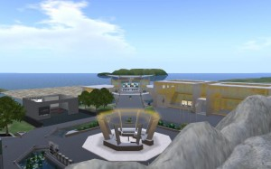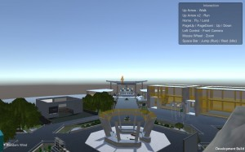
OAR Converter can run on Linux and Windows and source code is available. Full instructions for compiling and using the source code version on these platforms is available via the TUIS Wiki OAR Converter Page. For convenience a version with Windows UI is also available as a ready to run package.
OAR Converter with Windows User Interface – Quick Start
Download the OAR Converter for Windows latest version from http://www.nsl.tuis.ac.jp/xoops/modules/xpwiki/?OARConvWin
Latest Version in September 2017 is v1.0.6 (at 2016/5/11) which is based on oarconv-1.4.4.
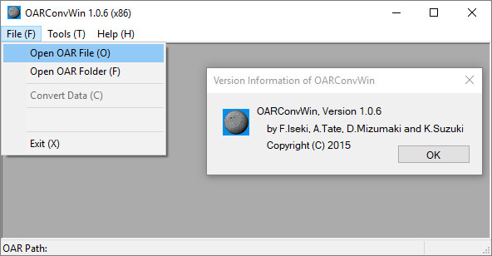
For straightforward conversions, simply follow these steps:
- Place your OpenSim OAR file in a suitable directory. Using defaults, the conversions will be placed in separate directories in this same directory with names based on the OAR file name prefixed by OAR_ and DAE_
- Run the OAR Converter and using “File” -> “Open OAR File” select the OAR file you wish to convert. This will create a directory called OAR_ with the unpacked contents of the OAR file ready for conversion.
- Now select “File” -> “Convert Data” from the OAR Converter File menu. This will create a directory called DAE_ with the converted content in it.
- The DAE_ directory created will contain the DAE/Collada objects for the conversion which have colliders (are solid) and one special DAE/Collada object for the terrain (named the same as the OpenSim region name). It will also have sub-directories for all Textures and for the Phantoms (objects with no collider).
Import to Unity3D
You could follow the video instructions in this YouTube video by Fumikazu Iseki. First part of this video shows the use of the Linux converter, but the part from [2:23] to [6:10] gives an example of importing the converted DAE/Collada folder contents and merging that with a Unity project/scene including adding a Unity Standard Asset water surface. Importing the included “UnityChan” character is shown in the last part of the video.
Import to Unity3D – Quick Start
- Ensure you add the contents of “forUnity3D” folder in the OAR Converter distribution into your Unity project, adding Editor/SelectOARShader.cs at least. A slight improvement to one file in this distribution is available… the file in forUnity3D/Editor named SelectOARShader.cs can be replaced with a version which fixes materials on bright objects imported to Unity. Replace it with UnitySelectOARShaderBrightFixed.cs [directory for right-click download] [direct link]. Don’t leave both versions in place.
- In your Unity project add an empty game object at 0,0,0 and name it the same as your OpenSim region name. Under this add three empty game objects named Solid, Phantom and Terrain also at 0,0,0.
- Drag the DAE_ folder in its entirety onto the Unity “Project” (Assets) panel.
- Select all the objects in the top level of this directory except the Textures and Phantoms sub-directories and drag them onto the “Solids” game object in the Unity “Hierarchy” panel.
- Optional: As the (large) terrain object for the region is imported it is usually split automatically by Unity into three sub-meshes of less than 64k polygons. These are all under one object named the same as your OpenSim region and will have sub-mesh names starting “GEOMETRY_”. You may wish to move this terrain objects and its three parts to the “Terrain” object in the hierarchy for
- Select all the objects in the Phantom directory and drag them onto the “Phantoms” game object in the Unity “Hierarchy” panel.
- Optional: Add a water layer at 0,0,0. [Instructions in YouTube Video][2:23] to [6:10].
- Optional: Add a ThirdPartyController/Avatar to be able to run the scene and view the contents. [Instructions in YouTube Video] after [6:10].
Project Base for OAR Converter Projects
Once you have successfully tried a conversion and understand the elements, you may wish to create a base for any future OAR conversion… which can include all the steps except for the drag and drop in of the actual DAE converted content. Do this yourself to incorporate the very latest OAR Converter content, scripts and Unity assets. You can if you wish save this as a “unitypackage” to incorporate into future Unity projects.
Make a copy of the base project you created or a new unity project, import the chosen unitypackage as a base, and then drag the OAR Converter produced “DAE” directory into the Unity Project Assets area, add the DAE folder assets and those in the DAE/Phantoms folder to the hierarchical view panel. Adjust the position of the chosen character and attached camera to suit the region, save the project, save the scene, and you should be good to go.
Access via a Virtual World – Sinespace
The region can be made available for use by multiple simultaneous users using Massive Multiplayer Online (MMO) servers or platforms. One example is Sinespace.
For more details see the Sinespace Wiki or tutorial videos:
- Sinespace – Getting Started
- Sine space – Region – Minimum Requirements
- Region Setup Video
The OAR Converter creates a lot of materials with repetitive (identical) textures. These are used to maintain other properties of materials such as shininess used by the Shader used to import OAR Converted content (via Editor/SelectOARShader.cs). This leads to rather large regions in Sinespace and hence larger than necessary download sizes for users using the content. The Sinespace developers have provided a useful and effective tool to reduce the repetitive textures used without effecting the visual appearance of the imported content. Always use this tool before uploading the region containing OAR Converter content before uploading a region to Sinespace. Use it via the Unity3D “Sine” -> “Tools” -> “OAR Material Cleanup” menu. The Sine menu is added to Unity when the Sinespace unitypackage is imported as described in “Sinespace – Getting Started”.
In recent versions of Unity and Sinespace there can be some bright emissive objects created by the OSAR Conversion process which are due to the use of “Legacy” shaders in Unity. These can be changed to Standard shaders (Standard/Diffuse or Standard/Diffuse-Emissive) in a bulk fashion, but some manual tidyup afterwards might be necessary especially to correct for the addition of shininess and metallic effects, and for emissive and semi-transparent objects.

