Virtual Worlds

I-Room: Augmenting Virtual Worlds with Intelligent Systems
Austin Tate
Artificial Intelligence Applications Institute, University of Edinburgh
An I-Room is a virtual world “intelligent room” that can support collaborative meetings and activities, especially when these involve sense-making about a current situation, planning, considering options, and decision making. The combination of a virtual worlds meeting space and intelligent systems to support planning and decision making in an I-Room provides a readily understandable framework and generic architecture for a wide range of potential collaborative applications and uses.
Military command posts and civilian emergency operations centers provide a nexus where a team of decision makers can come together to gather information, understand a situation, and make decisions in crisis situations, during disasters, and when an organization or region is under threat. But often, these decision makers are distributed and can’t be called together physically.
Whereas most 3D virtual worlds have been used as social networking or sales venues, universities and businesses have considered other uses, finding such worlds especially effective for teaching and collaborative meetings. Relatively few serious applications (sometimes called “serious games” because they use gaming technology for a serious purpose) have been studied in 3D virtual worlds.
For some years, the University of Edinburgh has been developing intelligent systems to support planning, collaborative option generation, plan critiquing, and adaptive plan execution in very dynamic situations. Over the past few years, we’ve linked these technologies together with a virtual interactive meeting space to provide an I-Room — a virtual space for intelligent interaction. Applications to date include emergency response operations centers used for experimentation and exercises, support to a geographically dispersed cross-disciplinary team engaged in creating multimedia products, and even a commercial application involving expertly tutored whisky-tasting and sales. Here, I describe I-Room technology and its collaborative uses.

The I-Room
An I-Room is an environment for intelligent interaction. It can provide support for formal business meetings, tutorials, project meetings, discussion groups, and ad hoc interactions. Users can employ the I-Room to organize and present pre-existing information as well as display real-time information feeds from other systems such as sensor networks and Web services. It can also help participants communicate, incorporate voice channels and teleconferencing, facilitate interactions, and record and act on the decisions taken during a collaboration.
Using the I-Room concept within virtual worlds gives a collaboration an intuitive grounding in a persistent 3D space in which participants’ representations (avatars) appear, and the artifacts and resources used in the collaboration are close at hand (see Figure 1). Avatars can meet each other “face-to-face” in a virtual world when their human counterparts can’t. Some benefits of a real-world meeting are retained through immersion in the virtual world, and in some cases virtual world meetings might be an effective alternative to face-to-face meetings, telephone calls, or video conferences.

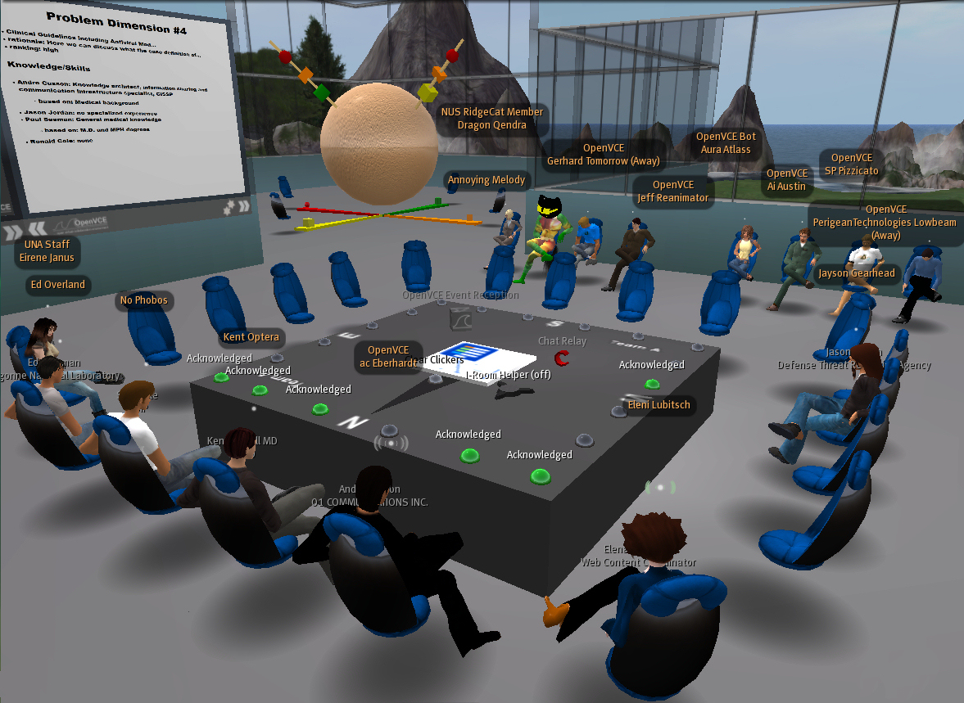
Figure 1. I-Room showing live information feeds and links to external data sources.
Beyond the advantages a shared interaction space confers, the I-Room can help deliver intelligent systems support for meetings and collaborative activities. In particular, we designed the I-Room to draw on I-X Technology,1 which provides human participants with intelligent and intelligible task support, process management, collaborative tools, and planning aids. The I-Room can also utilize a range of manual and automated capabilities or agents in a coherent way. Participants share meaningful information about the processes or products they’re working on through a common conceptual model called <I-N-C-A> (Issues-Nodes-Constraints-Annotations).2 The I-Room framework is flexible enough to provide participants in I-Room meetings with access to knowledge-based content and natural-language-generation technology that tailors utterances to users’ specific experience levels.

Intelligent Systems Technology
One key intelligent system used in the I-Room is the I-X Technology process support framework and I-Plan.1 I-Plan is an intelligent planning aid that can offer task-support help, generate and refine plans to adapt them to the situation at hand, support the execution of standard operating procedures, support the various stages of conducting a meeting, help handle post-meeting group actions, and so on.
Decision makers could use the original I-X/I-Plan collaborative planning technologies when local or remote from one another by interacting through a shared Web interface. The I-X tool suite includes simple chat and information exchange capabilities (using, for example, Jabber/XMPP messaging) for discussions between multiple users such as decision makers and specialist planners. However, the technologies lacked a simple and intuitive means to enable awareness of other decision-making agents’ presence or share artifacts, and voice and video weren’t used.
With the advent of 3D virtual worlds (for example, Second Life and OpenSimulator), our team was able to link I-X technologies so that they could support a community connected via such a virtual worlds meeting space. The flexibility of typical scripting facilities in virtual worlds and their ability to easily connect with external Web services made the integration of the intelligent systems relatively easy without requiring fundamental changes to how the decision-support systems operate. Virtual worlds also support good connections to Web-based static media and dynamically generated Web content and can connect with live media streams, which facilitate a common, shared real-time view of presentations and excellent links to video teleconferencing for mixed reality events. In some applications, an avatar within the virtual world presents a “camera” view of a collaborative meeting such that it can be relayed to Web observers — that is, users who connect only via Web presentations technologies such as Adobe Connect. This has enabled voice, video, text chat, and presentation sharing across the virtual world and Web observer communities to extend the reach to users unable to connect directly for security, firewall, or management reasons.

I-X Technology and I-Room Meeting Support
As mentioned, I-X Technology provides intelligent task support, planning capabilities, and coordination between multiple agents.1 It provides a user interface called an I-X process panel (I-P2)3 that acts as a sophisticated “to-do” list. An I-Room created within a virtual world such as Second Life or OpenSimulator can be linked to I-X systems and agents external to the virtual world to support collaborative meetings in virtual worlds or in mixed reality alongside real-world meeting locations. It can support common requirements for meetings by
automatically generating a framework for the meeting, including generic agenda items (such as review of previous actions, “any other business”, and the agreed-on date for the next meeting);
- keeping track of actions and agenda items during the meeting itself;
- recording decisions and taking minutes;
- tracking existing actions and adding new ones;
- providing access to minutes from previous meetings; and
automatically generating an outline of the meeting minutes.
Through an object in the virtual world, called the I-X helper, the I-Room can sense avatars’ presence and respond to commands directed to it. The I-Room can provide additional support by
monitoring participants’ comings and goings in the meeting;
- prompting in-world “screens” to display the meeting agenda or any relevant images, media, documents, or webpages at appropriate times during the meeting; and
unobtrusively documenting the meeting’s progress and outcomes.
Although some of these tasks are simple, the I-Room can perform others well only if it has access to knowledge about meetings in general and the current meeting and participants in particular. Linking the I-Room to real-world knowledge-based systems can potentially extend the support they offer into this virtual space, thereby distributing the knowledge they embody.4

Underlying Concepts for I-Room Collaboration
Underlying the use of the I-Room for collaboration and its ability to link human participants to intelligent systems support are the following concepts:
a mixed-initiative collaborative model for refining and constraining processes and products;
- communication based on sharing issues, activities and processes, state, events, agents, options, argumentation, rationale, presence information, and status reports;
- the use of the <I-N-C-A> ontology for representing the processes used and products developed during meetings;
- I-X Technology and its suite of tools to provide task and process support;
- the use of issue-based argumentation about options;
- the use of agent presence models, as in instant messaging, and awareness of agent context, status, relationships within an organizational framework, capabilities, and authorities; and
external shared repositories of descriptions of processes, products, and other domain-defined objects.
Together these provide a principled, intelligible, and extendable basis for collaboration between the people and systems involved.

Connecting an I-Room to a Virtual World
Meeting participants in an I-Room log in via their avatar in a virtual world viewer. The I-X helper, which can be any convenient object in the virtual world, contains scripts that act as a conduit for channeling communications to the participants connecting via their avatars. The I-X helper communicates through one nominated I-X agent to the various I-X services via a communications channel (which, for Second Life, for example, uses a mixture of HTTP requests and responses and communications via XML RPC). Messages from either end can be queued and sent later if the I-X helper or the nominated I-X agent aren’t available.
The I-X helper can communicate with avatars in the I-Room via text chat channels in the virtual world. It also uses dedicated private channels to communicate with and control suitable devices in the virtual world, such as screens. The helper can operate such devices within an I-Room by loading a note card held within the virtual world itself that contains a description of the virtual world capabilities it should know about, and information on how to communicate instructions to those capabilities. Specific capabilities to provide flexible display of images, external webpages, and I-X agent-oriented information are also incorporated. The I-X helper provides a sensor for determining when avatars come into range, so that the helper can report them as joining and leaving the I-Room or meeting. The I-X helper also listens on a specific chat channel for instructions that it can handle itself either using external I-X services or virtual world agents, or object capabilities it’s told about through the capabilities note card. This lets avatars and other objects in the virtual world use the I-X helper to request services, such as noting action items or taking minutes and recording decisions. In general, it also lets I-Room participants interact with external I-X agents and lets those agents communicate with and control devices in the virtual world (see Figure 2).

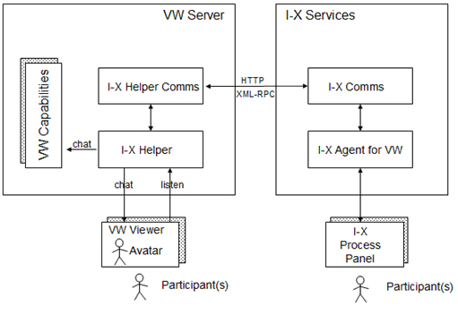
Figure 2. The I-X helper connects the virtual world to I-X services such as planning aids and knowledge-based systems
More details about I-Rooms and the ways in which we can use them in virtual worlds is available at http://openvce.net/iroom.

I-Room Applications
At the University of Edinburgh, we have deployed I-Rooms in Second Life (on publicly accessible areas) and in OpenSimulator (on privately hosted servers that can run behind secure firewalls, if necessary). The software for the external I-X services and an example virtual-world-based I-X helper are available as open source code. We’ve provided sample I-Room 3D models that support the workflow in typical operation centers — for example, with a central meeting space and surrounding work zones based on the flow of “observe, orientate, decide, act” (the “OODA Loop”) alongside the software to make for simple deployment and set up for trials.
Some I-Rooms have been running continuously since early 2008, and a number have been used for live events, workshops, collaboration meetings and discussions, training exercises, product design and review meetings, scientific project reviews, social occasions, and so on. This has included meetings in which participants have been located on three continents. Some I-Rooms are constantly available to their users through publicly accessible virtual worlds such as Second Life. Others are deployed rapidly (within minutes) on demand. The Artificial Intelligence Applications Institute (AIAI) at the University of Edinburgh regularly opens an I-Room in support of teleconferences to give a visual indication of presence, rich media sharing, and simple ways to initiate back-channel interactions for participants, even when traditional video and audio channels outside those available through the virtual world are in use with collaborators. We’ve worked with companies such as Disney, EADS (Airbus), Glenkeir Distilleries/The Whisky Shop, Kodak, Slam Games, and others.
I-Rooms are also being applied to a range of national and international crisis and emergency response situations,4 homeland security, unmanned aerial vehicle (UAV) mission monitoring, team training, and simulation exercises. One series of experiments for the Whole of Society Crises Response Community (WoSCR) involved a regional response to an escalating swine flu incident.5 WoSCR used a virtual world I-Room for meetings, alongside a Web 2.0 team collaboration website and wiki. We performed an evaluation via questionnaires during and after the experiments, and the participants reported that the facilities offered positive advantages over traditional methods of meeting and sharing information, which usually involve teleconferences, email, and file sharing.
An I-Room provides a shared persistent space with intelligent systems support for interaction and collaboration between users, systems, and agents. It allows for the integration of a range of intelligent system aids, services, and agents into the meeting. An I-Room consists of elements inside a virtual world and external knowledge-based and intelligent systems. This especially includes the I-X planning, process, and task support aids, but has also involved knowledge-based and expert systems to access large semantic knowledge stores, and natural-language-generation capabilities.
At the University of Edinburgh, we’re refining the core I-Room artificial intelligence concepts and technology and making them more generic. This work includes the development of generalized links to knowledge-based systems; capability modeling to identify and exploit opportunities in virtual worlds; and semantic tagging of various media and communication streams that constitute a virtual meeting to allow a higher level of context-sensitive support, with documentation, indexing, and playback facilities. We’re creating several virtual world capabilities to augment I-X support for intelligent interaction in virtual meeting spaces, virtual operations centers, and training rooms. Work is also under way to explore the synergy between physical instrumented meeting spaces and virtual-worlds-based I-Rooms to better support collaborative distributed decision-making groups.
We’re able to provide intelligent decision-support tools independent of virtual worlds, but our experience indicates coupling them has advantages. Intelligent systems can be layered on top of existing virtual worlds platforms, and this is facilitated by scripting facilities in the object-oriented programming environments that many flexible virtual worlds provide.

Acknowledgments
The I-X and I-Room projects have received funding from several sources, including DARPA, the US Joint Forces Command/Army Research Labs/Alion (OpenVCE.net project), the European Regional Development Fund, and the School of Informatics at the University of Edinburgh. The university and project funding partners are authorized to reproduce and distribute reprints and online copies for their purposes notwithstanding any copyright annotation hereon. The views and conclusions contained herein are those of the authors and should not be interpreted as necessarily representing the official policies or endorsements, either expressed or implied, of other parties.

References
1. A. Tate, “Intelligible AI Planning,” Proc. 20th British Computer Society Special Group on Expert Systems, Int’l Conf. Knowledge Based Systems and Applied Artificial Intelligence (ES 2000), Springer, 2000, pp. 3–16.
2. A. Tate, “<I-N-C-A>: An Ontology for Mixed-Initiative Synthesis Tasks,” Proc. Workshop on Mixed-Initiative Intelligent Systems (MIIS), Int’l Joint Conf. Artificial Intelligence (IJCAI 03), ijcai.org, 2003; www.aiai.ed.ac.uk/project/ix/documents/.
3. A. Tate, J. Dalton, and J. Stader, “I-P2 — Intelligent Process Panels to Support Coalition Operations,” Proc. 2nd Int’l Conf. Knowledge Systems for Coalition Operations (KSCO 02), ksco.info, 2002, pp. 184–190.
4. A. Tate et al., “I-Room: A Virtual Space for Intelligent Interaction,” IEEE Intelligent Systems, vol. 25, no. 4, 2010, pp. 62–71.
5. A. Tate et al., “Virtual Collaboration Spaces and Web 2.0: Bringing Presence to Distributed Collaboration,” Reshaping Research and Development Using Web 2.0-Based Technologies, M. Baker, ed., Nova Science Publishers, 2011.

Austin Tate is the director of the Artificial Intelligence Applications Institute (AIAI) and holds the Personal Chair of Knowledge-Based Systems at the University of Edinburgh. His research interests include emergency response using advanced knowledge and planning technologies, and collaborative systems, especially using virtual worlds. Tate has a PhD in machine intelligence from the University of Edinburgh. He’s a fellow of the Royal Society of Edinburgh, a fellow of AAAI, and an IEEE Intelligent Systems senior advisory board member. Contact him at a.tate@ed.ac.uk.
Keywords: collaborative computing, artificial, augmented, and virtual realities, artificial intelligence

