**Virtual Operations Centres for Coalition Operations and Distributed Team Collaboration**

Austin Tate <a.tate@ed.ac.uk>

AIAI, University of Edinburgh, Informatics Forum, Crichton Street, Edinburgh EH8 9AB, U.K.

Jeffrey T. Hansberger <jeffrey.t.hansberger.civ@mail.mil>

U.S. Army Research Laboratory HRED, Redstone Arsenal, Alabama 35898-7290, U.S.A.

**Abstract**

On-line multi-user virtual worlds have been used to create collaboration environments and shared virtual spaces to allow distributed teams to train, exercise or work together. Platforms such as Linden Lab's Second Life™ or the open source community's OpenSimulator have been used to provide easily accessed facilities in which users are represented by avatars in a space designed to support their collaboration and sharing of resources. The creation of a suitable virtual space allows users wherever they are located to be brought together into a shared visualisation of an "operations centre". This may be joined with real operations centre(s) to integrate a distributed team to allow them to more effectively address the task or operations they are engaged in. Such environments are particularly well suited to training and exercises, but can also be used for real events when distributed teams are involved.

The paper describes the "Open Virtual Collaborative Environment" (OpenVCE) and its facilities, and how the resources have been made widely available as a basis for creating customised environments and used for multi-national and multi-agency team collaboration facilities especially where teams are geographically distributed.

**Introduction**

On-line multi-user virtual worlds have been used to create collaboration environments and shared virtual spaces to allow distributed teams to train, exercise or work together. Platforms such as Linden Lab's Second Life™ or the open source community's OpenSimulator have been used to provide easily accessed facilities in which users are represented by avatars in a space designed to support their collaboration and sharing of resources. The creation of a suitable virtual space allows users wherever they are located to be brought together into a shared visualisation of an “operations centre”. This may be joined with real operations centre(s) to integrate a distributed team to allow them to more effectively address the task or operations they are engaged in. Such environments are particularly well suited to training and exercises, but can also be used for real events when distributed teams are involved (Tate, 2006).

This paper describes work on the “Open Virtual Collaboration Environment” (OpenVCE), a project which explored openly accessible platforms, tools and protocols to support distributed team collaboration. The paper has a focus particularly on the provision of virtual world operations centres for both training exercises and actual emergency response.

**Emergency Response**

The desire to support the collaborative development of responses to large-scale emergency crises provided the impetus for the work described here, although the lessons learned should be applicable to other types of interaction. Crisis response situations require collaboration among individuals belonging to many different organizations and having different backgrounds, training, procedures and objectives. The response to the Indian Ocean Tsunami in 2004 and the Hurricane Katrina relief efforts in 2005 emphasized the importance of effective communication and collaboration. In the former, the Multinational Planning Augmentation Team (MPAT) supported brokering of requests for assistance by matching them with offers of help from deployed military and humanitarian assistance facilities. In the aftermath of Hurricane Katrina, the U.S. Army and National Guard assisted state, federal, and non-government organizations with varying degrees of efficiency and expediency. Compounding the challenges associated with such situations is the distributed nature of the community of experts who can contribute to the analysis of the crisis and the planning of a response. As a result, opportunities for leveraging expertise and resources across organizations are haphazard at best, and the response to the crisis can appear as chaotic as the crisis itself.

Seeking more effective and efficient means to facilitate crisis response, in 2009 the U.S.U.S. Joint Forces Command (USJFCOM) and the U.S. Army Research Laboratory’s Human Research and Engineering Directorate (ARL HRED) launched a project under the direction of one of the authors (Hansberger) to design and evaluate a Virtual Collaboration Environment (VCE), and to seek to demonstrate its potential for distributed crisis response planning. More broadly, the project sought to discover implications for any distributed collaborative activity.

**Virtual Collaboration Environment Concept**

The initial technical concept behind the VCE was to investigate the potential of new media technologies, specifically social networking and virtual worlds, to provide a virtual environment that fosters community spirit and collaborative effort in some particular field (a field in which, we assume, there exists a potential community of users who have complementary knowledge or skills that contribute to problem-solving). Thus envisaged, the VCE was planned to meet several specific requirements:

* The creation and maintenance of a community of on-line users with diverse backgrounds (including those with little or no prior experience of virtual or on-line communities). In the first instance, the VCE was intended to support a “Whole of Society Crisis Response” (WoSCR) community, a loosely affiliated community of subject-matter experts and crisis responders drawn from international government and civilian organizations for the purpose of contributing their specialised knowledge to crisis response planning activities. In the course of the project an initial mailing list of 1,600 people already involved in such activities was used to establish the community, of which some 300 were active within the VCE facilities that were provided. It contained members from a number of countries (although initially with a strong U.S. bias) drawn from the worlds of government, business and academia.
* The ability for users to conduct *synchronous* collaborations for the purpose of collective decision-making during specific problem-solving episodes.
* The provision for the users of mechanisms for the *asynchronous* creation and development of on-line material. This has two aspects: the short-term development of informational material as a part of the problem-solving process; and the long-term development of an on-line body of experience, knowledge and debate about the field in question.

Hence, collaborations in the environment would have two, quite different, aspects: a continuous asynchronous collaboration among users to discuss and develop on-line documentation pertaining to their field of interest (activities which would also help foster a sense of community); and interspersed synchronous problem-solving collaborations of relatively short duration in which their expertise is put into practice. It was envisaged that web and virtual worlds’ technologies together would provide the technical backbone for meeting these requirements.

**Virtual Collaboration Environment Requirements and Design**

The designers and developers of the VCE included groups from the University of Edinburgh, the University of Virginia, Carnegie Mellon University and Perigean Technologies LLC, each of which had an existing and complementary interest in collaborative work and so would bring specialised knowledge or technology to the programme. Therefore, the U.S. Army Research Laboratory and these partners engaged in the creation of an openly accessible "Virtual Collaborative Environment" (VCE) to support the "Whole of Society Crisis Response" (WoSCR) community of interest involved in crisis action planning and execution activities (Hansberger et al., 2010) and also in the later work to support the "Dismounted Infantry Collaboration Environment" (DICE) for remote support to medics supporting injured soldiers (Tate et al., 2012).

The VCE consists of a collaborative portal containing a suite of Web 2.0 social networking and group support tools including data visualisation facilities (Moon et al., 2011), a 3D virtual world collaboration space (Tate et al., 2010a) and a virtual collaboration protocol based on social science research (Cross and Parker, 2004) to assist the team members to work together effectively. The aim was to choose from and utilise appropriate capabilities from this suite of tools to meet the requirements of distributed collaboration for the target communities.

As a first step, in order to validate these initial assumptions, a Cognitive Work Analysis (CWA) (Vicente, 1999) was performed. All tools were selected to support the key functions identified in a Work Domain Analysis (figure 1) for distributed collaboration (more fully reported on in Tate et al., 2014). The CWA bottoms out in a number of types of tool or technology which “facilitate” the required communications methods and activities. This set of requirements and types of technology is used to guide selection and provision of key features in the experimental collaboration environment. The specific tools were also chosen to be open source or as accessible as possible to allow them to be made available to the wide range of organizations that make up the crisis response community. The tools support both synchronous activities which take place when team members meet and work together and asynchronous activities when they may work separately and contribute to the knowledge pool that the team is gathering.

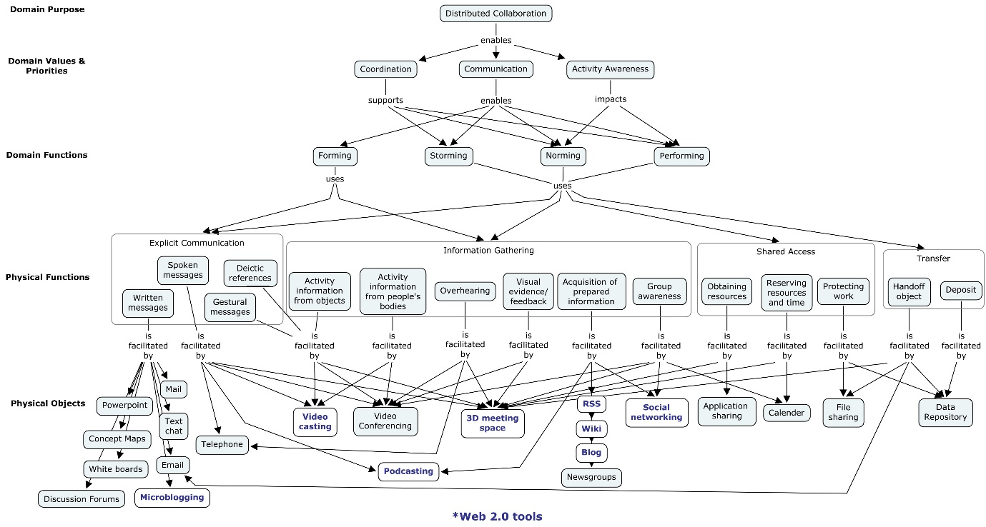

Figure 1: Cognitive Work Analysis Phase I – Work Domain Analysis (from Tate et al., 2014)

**Community Web Portal**

The VCE includes a web-based portal that provides the platform for collaboration and communication, and for creating and sharing resources, as well as more general group-building activity and event awareness (http://openvce.net – see Figure 2). After some experimentation and discussion, the open-source Drupal-based software system was adopted as the platform for this site. Drupal is a widely used modular content management system, with an active development community of its own. It provides a user management system and social web functionality such as user profiles, individual blogs and forums. The site was specialised with a range of modules to provide, for instance, twitter-like activity awareness, picture sharing and group management facilities to allow ad hoc teams to be constructed from among the membership as a whole for specific purposes (such as working on a specific response problem). It also includes mechanisms that establish relationships of individuals to the virtual space, allowing users to associate their virtual personae with their real life web profiles. Links are provided to allow users to “teleport” into relevant locations of the virtual world collaboration spaces. This site has been augmented by a wiki (powered by the popular open source MediaWiki software), to provide facilities for co-authoring text documents (a facility felt to be lacking at the time in Drupal).

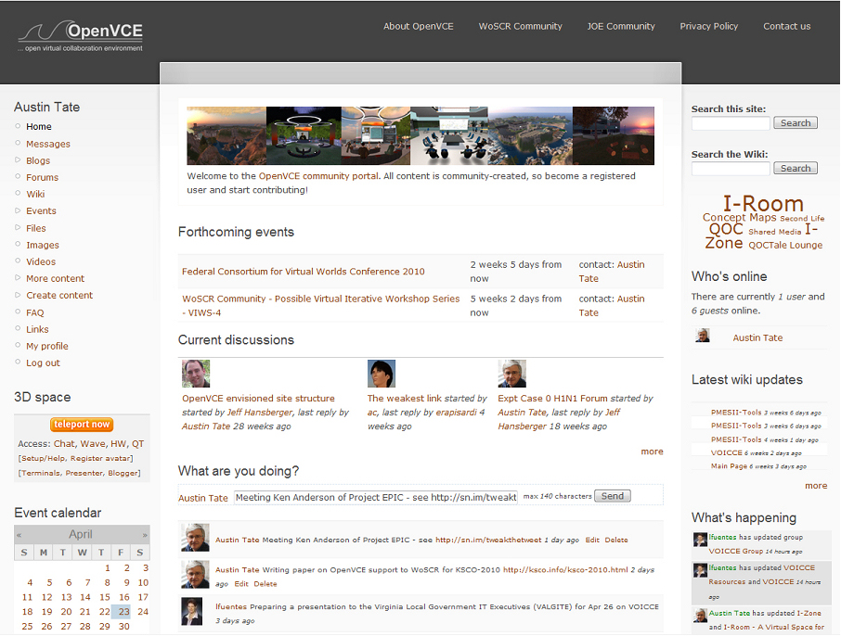

Figure 2: openvce.net web portal home page

This approach also allows for additional functionality to be made accessible to the community by embedding appropriate tools within site pages. These tools can be generic community tools or introduced for specific tasks such as supporting the team in option generation and pro/con argumentation.

**Virtual World Operation Centres – I-Rooms**

Warburton (2009) discusses the use of virtual worlds in educational contexts. He provides a table with a rich variety of synchronous and asynchronous communications and presence indication methods, as well as listing some of the issues for usability of virtual worlds like Second Life™ for education and collaboration. These indicate the particular niche which virtual worlds meeting spaces have in providing support to synchronous meeting facilities, as well as showing a large degree of overlap of the issues users have in using such spaces with those found during the OpenVCE project use by the WoSCR community.

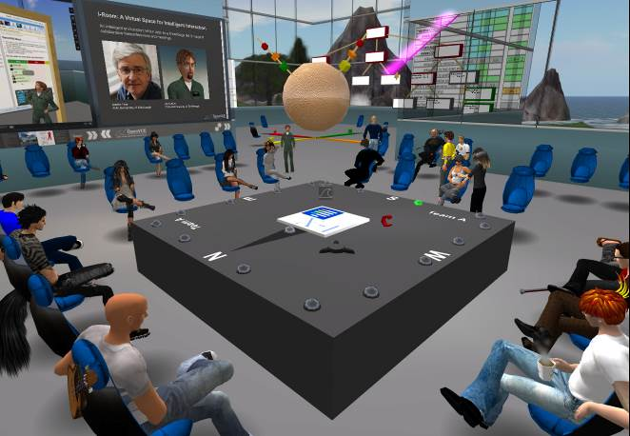

Figure 3: A synchronous meeting in a virtual world collaborative space with a range of experimental 3D visualisations for planning and option discussion

Second Life™ and OpenSimulator virtual world environments have been used to realise “I-Rooms” – virtual spaces for intelligent interaction (see figure 3). Using the I-Room concept within virtual worlds gives a collaboration an intuitive grounding in a persistent space in which representations of the participants (their “avatars”) appear and the artifacts and resources surrounding the collaboration can be granted a surrogate reality.

Although for the uninitiated the virtual space can initially be disorienting and video game-like, in our experience users quickly feel comfortable in the space once any technical issues are ironed out (as is the case for other video-conferencing systems, these issues are usually related to audio difficulties or firewalls). Through an avatar a user can see the avatars of other users of the space, and communicate with those in earshot using spatialised voice (communication is also possible using general text chat and instant messaging). This audio-visual positioning in 3D space provides a compelling sense of shared presence with any other users currently in the same space.

In addition to its use as a distributed access meeting space, the I-Room can be used to deliver intelligent systems and tool support for meetings and collaborative activities. In particular, the I-Room is designed to draw on I-X technology (Tate, 2000) which provides intelligent and intelligible (to human participants) task support, process management, collaborative tools and planning aids to participants (Tate et al., 2010a). This technology encourages collaborators to share information about the processes or products they are working on through a common conceptual model called <I-N-C-A> (Tate, 2003). This framework allows access to automated capabilities or agents in a coherent way, providing participants in I-Room meetings with, for instance, access to knowledge-base content and natural language generation technology.

Figure 4 shows an I-Room in a virtual world viewer alongside a browser onto the web portal, typical of how a user’s screen might be laid out while using the VCE.

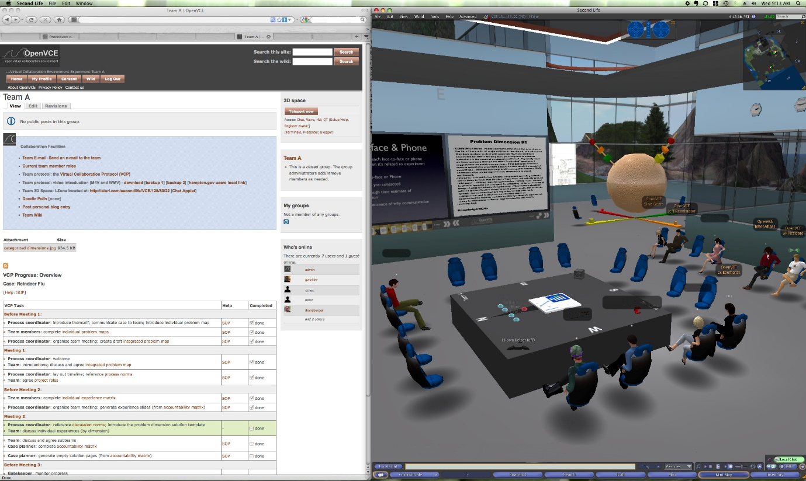

Figure 4: VCE web portal showing virtual collaboration protocol support, alongside an I-Room virtual world operations centre space

**Virtual World Collaboration Spaces**

The University of Edinburgh created a virtual world collaboration space with a range of facilities that could be provided in platforms such as Second Life™ and OpenSimulator. 3D modelling was provided by Clever Zebra to give professional spaces that could easily be selected or adapted for a range of purposes including:

* A central plaza where arrivals can be directed to appropriate spaces, meetings, events and given news. Users can also pick up (free) items to tailor their avatar or get assistive technologies to improve their access to the virtual collaboration spaces.
* A lecture style seated auditorium with stage space and multiple presentation screens.
* An exposition pavilion to allow for poster displays, demonstration booths and link ups to external web pages and active systems for further exploration. Non-player characters with chat bot capability could be in attendance at the stands when the project team members involved were not present.
* Project and group spaces where artifacts, maps, posters and information boards could persist to allow for small group meetings.
* Home bases and a range of informal meeting spaces to allow for voice and/or text chat discussions without interference with other spaces.
* I-Rooms: virtual spaces for intelligent interaction – an operations centre inspired brainstorming area surrounded by spaces for situation sense making, planning, decision making and communication, command and control purposes. (Tate et al., 2010b)

The collaboration "region" has been packaged as an open educational resource and made available in the Second Life™ marketplace and as a widely available OpenSimulator Archive (OAR) file. Several OpenSimulator-based grids offer the OpenVCE OAR as a starter region when they rent out virtual world space and it has been used in a number of educational environments (e.g., for an oil rig safety training environment, Tait et al., 2017).

MOSES is a virtual world research programme of the United States Army Advanced Training Systems Division (ATSD). The goal is to research and develop advances in virtual world technologies for use in simulation-based training. An OpenVCE region is available for demonstration purposes on MOSES (MOSES, 2017) and the OpenVCE OAR is provided via the MOSES web site for US government users and others to use and adapt to their needs (see figure 5).

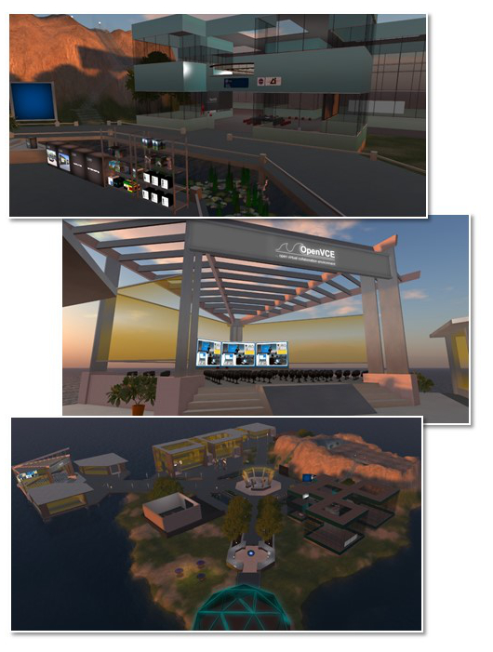Figure 5: OpenVCE Virtual World Collaboration Spaces as distributed in the MOSES OpenSimulator-based Virtual World Platform

As new forms of interaction with 3D and virtual environments evolve, such as using the Oculus Rift and HTC Vive VR headsets, the OpenVCE facilities become potentially even more useful. VR headsets have been used with the OpenVCE collaboration facilities and I-Rooms, especially in OpenSimulator, but also in emerging new platforms such as Linden Lab's Sansar, High Fidelity and Sine Space (Tate, 2015a). See figure 6 for an Oculus Rift “double barrel” virtual reality headset view of the OpenVCE region.

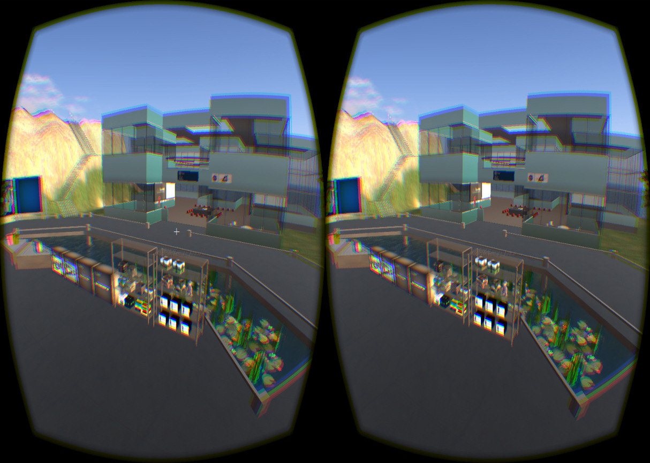

Figure 6: OpenVCE virtual world region as seen via the Oculus Rift virtual reality headset

An “OARConverter” tool (Iseki, 2015) (Tate, 2015b) to take content exported from OpenSimulator as an “OAR” – an OpenSimulator Archive file – via the portable Collada 3D model format into other 3D modelling environments such as Unity3D allows for the OpenVCE assets to be reused in these emerging platforms, extending the utility of the work (Tate, 2016). See, for example, figure 7 which shows the OpenVCE region in the Sine Space (<http://sine.space>) multi-user collaborative virtual world environment.

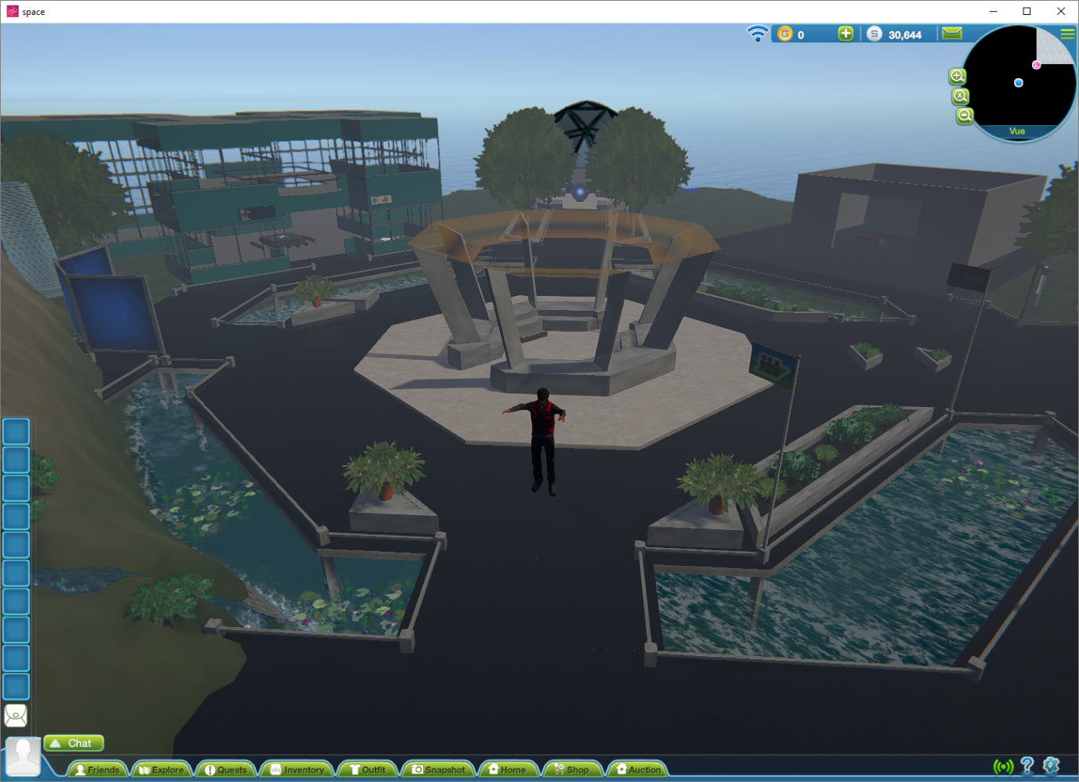

Figure 7: OpenVCE Virtual World Collaboration Spaces in Sine.Space after conversion from OpenSimulator through Collada and Unity3D to Sine.Space

**Simplifications of the Virtual World Collaboration Facility**

Later work on the Dismounted Infantry Collaboration Environment (DICE) which aimed to support medics treating injured soldiers and teh subsequent reviews of such cases (Tate et al., 2012) led to a simplified and uncluttered version of the virtual world-based I-Room in both Second Life™ and OpenSimulator (see figure 8).

This also was accompanied by a very much simplified entry web page to get users in quickly, and provide direct meeting support in the space. A lot of facilities provided for earlier demonstrations and experimental 3D visualisations in the previous WoSCR I-Rooms were removed to simplify new user engagement and interactions between team members.

The simplified DICE I-Room is included alongside the original I-Room and other collaboration and meeting facilities in the open source distributed versions of the OpenVCE virtual world assets, and in a demonstration environment hosted on the U.S. Army Research Laboratory's own MOSES OpenSimulator-based grid (MOSES, 2017).

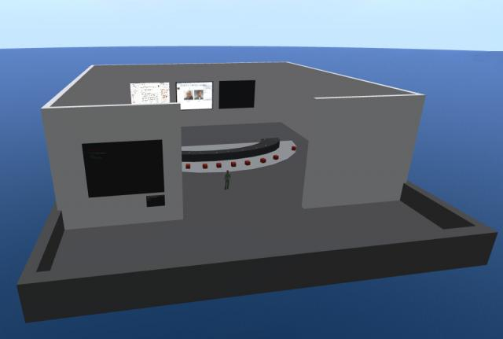

Figure 8: Simplified Virtual World Collaboration Space for DICE Project

**Experiments and Evaluation**

The VCE attempts to facilitate distributed collaboration by integrating asynchronous collaboration through social web technologies and synchronous collaboration through I-Rooms and virtual environments. Two experiments were conducted in 2010 to examine the impact the VCE had on crisis planning and collaboration when compared to traditional means of distributed collaboration among crisis response organizations and individuals. Results and conclusions from the second and more comprehensive of the two experiments are summarised here and reported on in more depth in Tate et al. (2014).

Background. The VCE experiment introduced a biological agent outbreak scenario to two teams of equally staffed crisis expert volunteers distributed across the U.S., U.K., Canada and Italy. The traditional group (control condition) used technology and means that would normally be used for distributed collaboration across these types of organisations (government, industry, non-government, military, and academia) during a crisis, including e-mail for asynchronous collaboration and telephone and teleconferencing for synchronous collaboration. The virtual group (experimental condition) used the full capability of the VCE as described in this paper for synchronous and asynchronous collaboration.

Participants. The virtual group consisted of 10 participants and the traditional group had 7 participants due to 3 individuals who were not available to participate. Each group had what was considered equal expertise in crisis response and biological outbreaks and had no prior experience working with each other. The groups each had at least one international member and had representatives from government, academic, non-profit, and industry organisations. Each group was given the same scenario and asked to generate a crisis response plan over four days.

Communication Patterns. The distribution and quantity of e-mails for each group was analysed as an indicator of their patterns of asynchronous communications. The basic pattern of most e-mails being addressed to the entire group was similar across both groups. However, the virtual group sent 38% fewer e-mails through the 4-day planning effort compared to the number of e-mails sent by the traditional group. A large difference in the patterns of communication was that the virtual group made heavy use of the online portal pages, forum, and wiki capabilities that produced a total of 2098 total page views or visited within the site. These results indicate that the asynchronous communications were different and that the virtual group did in fact use the portal capabilities for communication though they had the choice of using only e-mail for their asynchronous communication needs.

Uncertainty. Among one of the measurements taken each experiment day was a measure of uncertainty for each participant. Uncertainty was evaluated along two dimensions, namely goal and procedural uncertainty. Goal uncertainty is defined as the level of ambiguity a person has about the goals or objectives in their current situation or task. Procedural uncertainty, on the other hand, is how much ambiguity is associated with the steps or procedures necessary to accomplish the defined goals. Two seven-point Likert scale items measured each uncertainty dimension, which were averaged together. Choo (2005) has defined these uncertainty dimensions in terms of their interactions with each other. The amount of goal and procedural uncertainty possessed by an individual and group will dictate the mode (see Figure 9) of interactions and ultimately the success of the group.

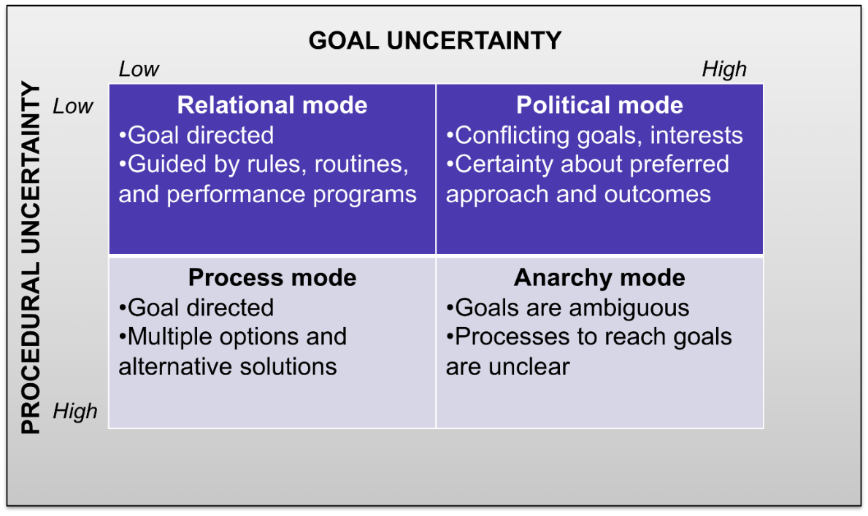

Figure 9: Goal and procedural uncertainty dimensions and the various modes of interaction they can create based on the levels of uncertainty for each dimension

Placing the results for goal and procedural uncertainty along the uncertainty dimensions presents a clear picture of how much uncertainty was involved for each group (see figure 10). The traditional group finds themselves interacting in the “anarchy mode” where there is ambiguity with both goals and procedures. Group and individual feedback after the experiment confirms this finding. There was considerable effort needed by this group to establish a common ground and understanding within the group before they could engage in any planning efforts. This is also indicative of collaboration efforts among many different organizations, involving people with different backgrounds and expertise, particularly when they have not worked together before. The virtual group using the VCE and virtual collaboration protocol fared much better and found themselves working within the “relational mode” where goals and procedures are clear and understood. The overall difference between the two groups was statistically examined using repeated measures analysis of variance (ANOVA) and there was a significant difference between the two groups as suggested in Figure 10 (F(1, 15) = 10.31, p < .01). The virtual group had less goal and procedural uncertainty as they collaborated with their colleagues, which can result in increased efficiency and performance.

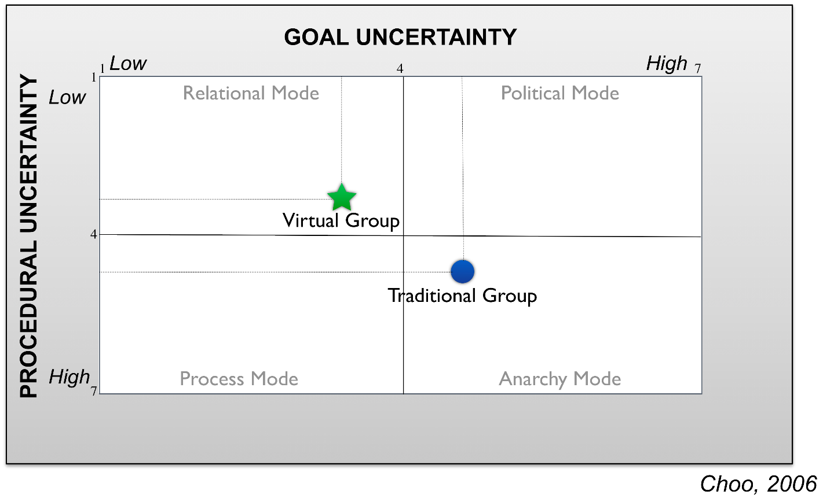

Figure 10: Goal and procedural uncertainty results from the virtual and traditional groups showing differences in uncertainty and the mode each group was interacting within

Time on task. The participants were asked to estimate the total time spent on planning efforts outside of their synchronous meetings. The self-reported average durations for the virtual group was 5.2 hours compared to 3 hours for the traditional group. An independent samples t-test showed that this difference was significant (*t*(8) = 2.88, *p <* .05). The virtual group has shown that they are communicating asynchronously differently than the traditional group and these results indicate that they spent more overall planning time as they were interacting with their teammates.

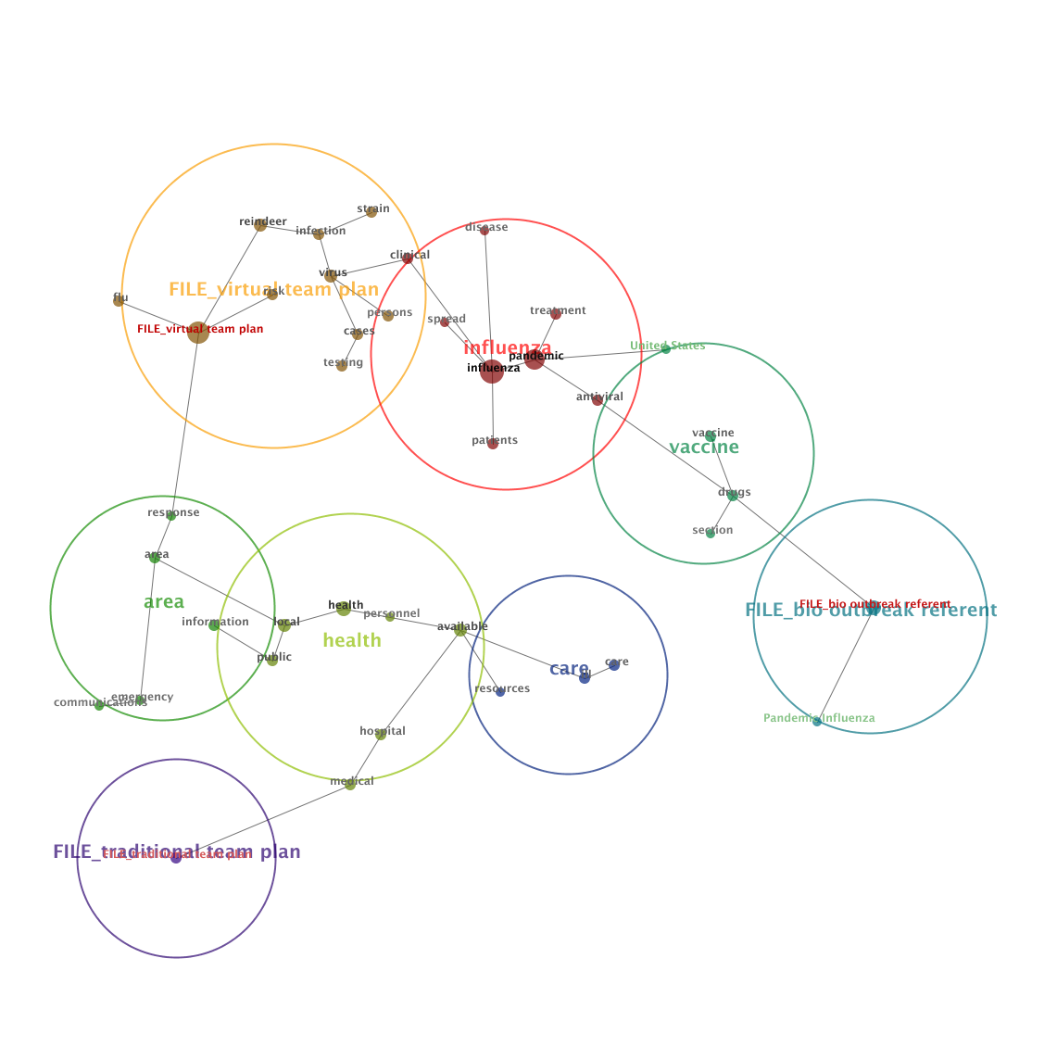Planning output. The final assessment area analysed the quality of their planning efforts. The participants were instructed to generate a planning document based on the crisis they were given. Their planning documents were analysed with text mining software called Leximancer ([www.leximancer.com)](http://www.leximancer.com)). This automated content analysis software was used to identify the semantic concepts addressed by each of the groups (Smith & Humphreys, 2006). Part of the output is a visual concept map that indicates the concepts in the document s produced and their relationships (figure 11).

Figure 11: Concept map that indicates automated content analysis of the semantic concepts addressed by each of the groups in the planning document they produced

In figure 11, both team plans can be seen (“FILE_virtual team plan” and “FILE_traditional team plan”) along with a “bio outbreak referent” which was based on a documented procedure for a biological outbreak response. The virtual team plan shows more depth due to its four originating concept links (flu, reindeer, risk, and response – each one level deep from the document root) versus the one concept link found with the traditional plan (medical). The virtual plan also displays greater breadth due to the larger number of concepts included in its plan versus the traditional plan. Finally, when each plan is compared to the bio outbreak referent plan, the virtual team shares a common concept group (vaccine) with the referent plan while none are shared with the traditional plan. These results suggest that the virtual group’s plan addressed more concepts, developed those concepts in more detail, and addressed concepts more similar to that of documented procedures compared to the plan the traditional group generated.

Results summary. The results when combined provide a possible explanation to the higher quality plan produced by the virtual group. The planning process begins and is facilitated through communication. The patterns of communications between the groups were shown to be quite different with the virtual group augmenting their e-mail communication extensively with the Web 2.0 capabilities found in the provided portal. These interactions by the virtual group resulted in less procedural and goal uncertainty, which could be the reason why the virtual group members chose to spend more time on their planning tasks compared to the traditional group members. If the end-goal is clear and the way to achieve that goal is clearly defined, it is much easier for individuals to spend time toward that task. Given that the virtual group spent more time on a task that they defined more clearly by means of their enhanced communication process, it is not surprising that they produced a higher quality plan in the end.

**Conclusion**

The Virtual Collaboration Environment (VCE) is based on a combination of Web 2.0 community knowledge sharing and collaboration tools which can be used asynchronously and a shared online virtual meeting space which can allow for synchronous meetings of the distributed team. A virtual collaboration protocol supports the activities of the group to improve the value of the environment to the participants.

A Cognitive Work Analysis was used to refine the requirements for a target community of experts engaged in support to large scale emergency crises and specific tools were selected to meet their needs. Experiments were performed in a number of emergency response simulations (based on a biological disease outbreak in a large city with input from an international team of experts) to show that there were improvements in Goal (Objective) definition and procedural (Decision and Action) outcomes when the virtual collaboration environment was used when compared to traditional telephone and teleconferencing support. Higher quality plans were produced by the team supported by the virtual collaboration environment.

The virtual world collaboration space, meeting support tools and associated content have been provided to allow others to use and customise the facilities for their own needs. The resources have been released under flexible open source as the Open Virtual Collaboration Environment (OpenVCE).

**Acknowledgements**

The OpenVCE project was funded by U.S. Joint Forces Command, the Army Research Lab and Alion Science and Technology Corporation. Specific applications mentioned in this article have been sponsored by a number of organizations. The University of Edinburgh, U.S. Army Research laboratory and research sponsors are authorized to reproduce and distribute reprints and online copies for their purposes notwithstanding any copyright annotation hereon. The views and conclusions contained herein are those of the authors and should not be interpreted as necessarily representing the official policies or endorsements, either expressed or implied, of other parties. Drupal is a registered trademark of Dries Buytaert and Second Life™ is a registered trademark of Linden Research, Inc. The authors acknowledge the contribution to the work presented herein of their colleagues from University of Edinburgh, the University of Virginia, Carnegie Mellon University, Perigean Technologies LLC and Clever Zebra, and that of the many volunteers and professional emergency responders who generously donated their valuable time and expertise to take part in the experiments.

**References**

Choo, C. H. (2005). The Knowing Organization: How Organizations Use Information to Construct Meaning, Create Knowledge, and Make Decisions. Oxford University Press, New York, NY.

Cross, R. and Parker, A. (2004) The Hidden Power of Social Networks: Understanding How Work Really Gets Done in Organizations, Harvard Business School Press.

Hansberger, J.T., Tate, A., Moon, B. and Cross, R., Cognitively Engineering a Virtual Collaboration Environment for Crisis Response, Proceedings of the 2010 ACM Conference on Computer Supported Cooperative Working. (CSCW 2010), Savannah, Georgia, U.S.A, 6-10 February 2010. Abstract and Poster.

Iseki, F. (2015) OARConv. http://www.nsl.tuis.ac.jp/xoops/modules/xpwiki/?OARConvWin

Moon, B., Hansberger, J.T. and Tate, A. (2011) Novakian Concept Mapping in Virtual Collaboration Environments. In: B. Moon, R.R. Hoffman, J. Novak and A. Canas (Eds.) Applied Concept Mapping – Theory, Techniques, and Case Studies in the Business Applications of Novakian Concept Mapping, CRC Press.

MOSES (2017) MOSES Military Metaverse – Downloads – Content – OpenVCE OAR. https://militarymetaverse.org/content

Smith, A.E. and Humphreys M.S. (2006). Evaluation of Unsupervised Semantic Mapping of Natural Language with Leximancer Concept Mapping. Behavior Research Methods, 38 (2), 262-279.

Tait, J., Hetherington, C. and Tate, A. (2017) Enhancing Student Employability with Simulation: The Virtual Oil Rig and DART, Poster Presentation, 3rd International Enhancement in Higher Education Conference: Inspiring Excellence - Transforming the Student Experience, 6th-8th June 2017, Radisson Blu Hotel, Glasgow, UK. The Quality Assurance Agency for Higher Education, UK.

Tate, A. (2000) Intelligible AI Planning. In Proceedings of ES2000, The Twentieth British Computer Society Special Group on Expert Systems International Conference on Knowledge Based Systems and Applied Artificial Intelligence, pp. 3-16, Springer.

Tate, A. (2003) <I-N-C-A>: a Shared Model for Mixed-Initiative Synthesis Tasks. In Proceedings of the Workshop on Mixed-Initiative Intelligent Systems (MIIS) at the International Joint Conference on Artificial Intelligence (IJCAI-03). Acapulco, Mexico, August 2003.

Tate, A. (2006) The Helpful Environment: Geographically Dispersed Intelligent Agents That Collaborate, Special Issue on "The Future of AI", IEEE Intelligent Systems, May-June 2006, Vol. 27, No. 3, pp 57-61. IEEE Computer Society.

Tate, A. (2015a) OpenVCE in Unity and VR, Blog Post, 5th October 2015. https://blog.inf.ed.ac.uk/atate/2015/10/05/openvce-in-unity-and-vr/

Tate, A. (2015b) OpenSim OAR Convert to Unity Scene with Windows Interface, Blog Post, 24th October 2015. https://blog.inf.ed.ac.uk/atate/2015/10/24/opensim-oar-convert-to-unity-scene-with-windows-interface/

Tate, A. (2016) Sine.space – OpenVCE Region, Blog Post, 15th November 2016. https://blog.inf.ed.ac.uk/atate/2016/11/15/sine-space-openvce-region/

Tate, A., Dalton, J., Stader, J., Wickler, G. and Hansberger, J.T. (2007) Collaborative Operations for Personnel Recovery Final Report on DARPA/AFRL Contract No. F-30602-033-2-0014, 31-Aug-2007 (revised 30-Jan-2008).

Tate, A., Chen-Burger, Y-H., Dalton, J., Potter, S., Richardson, D., Stader, J., Wickler, G., Bankier, I., Walton, C. and Williams, P.G. (2010a) I-Room: A Virtual Space for Intelligent Interaction, IEEE Intelligent Systems, Vol. 25, No. 4, pp 62-71, July-August 2010, IEEE Computer Society.

Tate, A., Chen Burger, Y-H., Dalton, J., Potter, S., Wickler, G., Carley, K.M., Kunkel, F., Cross, R., Hansberger, J.T. and Moon, B. (2010b), Open Virtual Collaboration Environment for the Whole of Society Crisis Response Community, Proceedings of the Sixth International Conference on Knowledge Systems for Coalition Operations (KSCO-2010) (Lawton, J. (ed.)), Vancouver, B.C., Canada, September 21-23, 2010.

Tate, A., Hansberger, J.T., Potter, S. and Wickler, G. (2012), Support for Distributed Collaboration in the Dismounted Incident Collaboration Environment (DICE), Proceedings of the Seventh International Conference on Knowledge Systems for Coalition Operations (KSCO-2012) (Lawton, J., Patel, J., Suri, N. and Tate, A. (eds.)), Pensacola, FL, U.S.A, February 15-16, 2012.

Tate, A., Hansberger, J.T., Potter, S. and Wickler, G. (2014) Virtual Collaboration Spaces: Bringing Presence to Distributed Collaboration, Journal of Virtual Worlds Research, Assembled Issue 2014, Volume 7, Number 2, May 2014.

Vicente, K. J. (1999). Cognitive Work Analysis. Lawrence Erlbaum Associates, Mahwah, NJ.

Wickler, G., Tate, A. and Hansberger, J.T. (2007) Supporting Collaborative Operations within a Coalition Personnel Recovery Center, Proceedings of the Fourth International Conference on Knowledge Systems for Coalition Operations (KSCO-2007) (Lawton, J., Patel, J. and Tate. A. eds.) pp. 14-19, Waltham, MA, U.S.A, 1-2 May 2007. In Proceedings of the International Conference on Integration of Knowledge Intensive Multi-Agent Systems Modelling, Evolution and Engineering (KIMAS '07).

Wickler, G., Tate, A. and Hansberger, J. (2013), Using Shared Procedural Knowledge for Virtual Collaboration Support in Emergency Response, in Special Issue on Emergency Response, IEEE Intelligent Systems, Vol. 28, No. 4, July/August 2013, IEEE Computer Society.